

DAEN 690

Project Report

Bhargav Dasari

Sagarika Komati Reddy

Venkata Krishna Kothapalli

Kamani Madasu

Uday Madivada

Suparna Mannava

Spring 2025

Disrupt Fentanyl Supply Chains: Illicit Synthetic Opioid (ISO) Determination Engine

**About the Cover**

This semester, the DAEN program is proud to spotlight one of our esteemed capstone partners, Daniel Erasmus a visionary whose groundbreaking work influences leaders worldwide. As the founder and CEO of Erasmus.AI, Daniel is a renowned futurist and a pioneer in scenario planning, artificial intelligence, and strategic foresight. His innovative approach to blending AI with human-centric decision-making has profoundly shaped global conversations on technology, sustainability, and future-readiness. Through his thought leadership, Daniel continues to inspire organizations across the globe to embrace change and build resilient futures.

At Erasmus.AI, Daniel conceived and led the development of ClimateGPT—the world’s first foundational AI model family focused on climate change. Built on over a decade of collecting and processing planetary-scale datasets, this groundbreaking innovation leverages AI to uncover hidden connections in global news, from Human-Centered Extreme Weather Dashboards to maps of global innovations, risks, and breakthroughs. The Erasmus.AI platform exemplifies his commitment to using technology to inform and address some of the world’s most pressing challenges.

As co-founder of The Digital Thinking Network (DTN), Daniel has spent over 25 years leading large-scale scenario planning and transformation processes. His work has driven notable actions, such as initiating a response to food security challenges during COVID-19 that delivered 1 million meals within three months and has since provided over 60 million meals in Sub-Saharan Africa. His scenario processes have also anticipated major global events, including the Global Financial Crisis in 2006 and the Oil Price Collapse in 2012—each resulting in multi-billion-dollar benefits for his clients. In the public sector, DTN's transformative initiatives include the Rotterdam Advisory Board, which spearheaded the Rotterdam Climate Initiative in 2005 with the ambitious goal of halving CO2 emissions by 2025, and the creation of the 30-year global future scenarios Ci’Num.

An accomplished author, Daniel has written three books on innovation and the networked society, as well as numerous columns, including the Information Society column for the Financial Times Review. He has also held various prominent board positions and fellowships, including serving on the University of Stellenbosch’s Faculty of Science Advisory Board, Cambridge-based Titan Advanced Energy Solutions, and the supervisory board of the Quad9 Foundation. Through his visionary leadership, Daniel continues to shape the future across disciplines and industries.

Contents

Table of Contents

Abstract 1

Section 1: Introduction 3

1.1 Report Purpose 3

1.2 Report Readership 3

1.3 Report Structure 4

Section 2: Problem Definition 4

2.1 Problem Space 4

2.2 Research 4

2.3 Solution Space 6

2.4 Project Objectives 6

2.5 Primary User Stories 7

2.6 Product Vision 7

2.6.1 Scenario #1 7

2.6.2 Scenario #2 7

Section 3: Datasets 8

3.1 Overview 8

3.2 Field Descriptions 10

3.3 Data Context 11

3.4 Data Conditioning 12

3.5 Data Quality Assessment 12

3.6 Other Data Sources 15

3.7 Data Sets Created 16

3.8 Storage Medium 22

3.9 Storage Security 22

3.10 Storage Costs 23

Section 4: Investigation and Exploration 23

4.1 Solution Approach 23

4.1.1 Systems Architecture 24

4.1.2 Syatems Security 26

4.1.3 Systems Data Flows 26

4.2 Running the Investigation 26

4.2.1 Preparing Data and Evidence 26

4.2.1.1 Algorithms & Analysis Methodology 27

4.2.1.2 Establishing & Maintaining Provenance 27

4.2.2 Accounting and Adjudicating Anomalies & Discoveries 27

4.2.3 Exploring the Solution Instrumentation (or Tooling) 27

4.2.3.1 Instrumentation Selection 28

4.3 Running the Instrumentation 28

4.3.1 Artificial Intelligence 28

4.3.2 Pulling It Together 31

**4.4 User Interface**…………………………………………………………………………………………………………………………………………….31

**4.5 Collaboration Between ISO Determiners and ISO Chemical ID Mappers**………………………………………………….47

Section 5: OUTCOMES AND VISUALIZATIONS 50

5.1 Over view 50

Section 6: Findings 51

Section 7: Summary 52

Section 8: Future Work 53

Appendix A: Domain Background 56

Appendix B: Glossary 59

Appendix C: GitHub Repository 61

Overview 61

GitHub Repository Link 61

GitHub Repository Contents 61

Appendix D: Risks 62

Sprint 1 Risks 62

Sprint 2 Risks 62

Sprint 3 Risks 63

Sprint 4 Risks 64

Sprint 5 Risks 65

Appendix E: Agile Development 67

Scrum Framework Team Approach 67

Sprint 1 Lessons Learned 68

Sprint 2 Lessons Learned 68

Sprint 3 Lessons Learned 68

Sprint 4 Lessons Learned 68

Sprint 5 Lessons Learned 68

References 70

Table of Figures

**FIGURE 1: USDOJ FENTANYL PRECURSOR CHEMICAL MANUFACTURING INDICTMENTS DATA SET**  8  
**FIGURE 2: FENTANYL PRECURSORS DATA SET**  9  
**FIGURE 3: INTEGRATED DATA AND EVIDENCE COLLECTION (COMPANY REFERENCE SHEET) DATA SET**  9  
**FIGURE 4: WEIGHTING TAG TYPE**  16  
**FIGURE 5: WEIGHTING TAG CATEGORY**  17  
**FIGURE 6: WEIGHTING TAG** 17  
**FIGURE 7: COMPANY WEIGHTING TAG**     18  
**FIGURE 8: WEIGHTING ROLLED UP TO COMPANIES**  18  
**FIGURE 9: SUBSTANCE WEIGHTING TAG** 19  
**FIGURE 10: WEIGHTING ROLLED UP TO SUBSTANCES** 19  
**FIGURE 11: EVIDENCE WEIGHTING TAG** 20  
**FIGURE 12: WEIGHTING ROLLED UP TO EVIDENCE** 20  
**FIGURE 13: OBJECT LOG** 21  
**FIGURE 14: ATTRIBUTE LOG**  21  
**FIGURE 15: DATA LOG** 22  
**FIGURE 16: SOLUTION SCHEMATIC** 24  
**FIGURE 17: SYSTEM ARCHITECTURE** 25  
**FIGURE 18: SECURE GPT INTERFACE** 29  
**FIGURE 19: RESULTS GENERATED BY SECURE GPT** 30  
**FIGURE 20: IMAGES EXTRACTED BY SECURE GPT** 30  
**FIGURE 21: ORGANISED DATA GENERATED BY SECURE GPT** 31  
**FIGURE 22: WEIGHTING TAG MANAGEMENT HOMEPAGE** 32  
**FIGURE 23: WEIGHTING TAG TYPE WITH CRUD DETAILS** 33  
**FIGURE 24: WEIGHTING TAG TYPE WITH CRUD DETAILS** 33  
**FIGURE 25: WEIGHTING TAG CATEGORY WITH CRUD DETAILS** 34  
**FIGURE 26: WEIGHTING TAG CATEGORY WITH CRUD DETAILS** 34  
**FIGURE 27: WEIGHTING TAGS WITH CRUD DETAILS** 35  
**FIGURE 28: WEIGHTING TAGS WITH CRUD DETAILS** 35  
**FIGURE 29: WEIGHTING TAGS WITH CRUD DETAILS** 36  
**FIGURE 30: SUBSTANCE WEIGHTING TAGS WITH CRUD DETAILS** 36  
**FIGURE 31: SUBSTANCE WEIGHTING TAGS WITH CRUD DETAILS** 37  
**FIGURE 32: ORGANIZATION WEIGHTING TAGS WITH CRUD DETAILS** 37  
**FIGURE 33: ORGANIZATION WEIGHTING TAGS WITH CRUD DETAILS** 38  
**FIGURE 34: EVIDENCE WEIGHTING TAGS WITH CRUD DETAILS** 38  
**FIGURE 35: EVIDENCE WEIGHTING TAGS WITH CRUD DETAILS** 39  
**FIGURE 36: USER INTERFACE FOR KEY VALUE SHEET & RISK ASSESSMENT MODEL** 40  
**FIGURE 37: DATA LOG WITH CRUD DETAILS** 40  
**FIGURE 38: DATA LOG WITH CRUD DETAILS** 41  
**FIGURE 39: DATA LOG WITH CRUD DETAILS** 41  
**FIGURE 40: ATTRIBUTE LOG WITH CRUD DETAILS** 42  
**FIGURE 41: ATTRIBUTE LOG WITH CRUD DETAILS** 42  
**FIGURE 42: ATTRIBUTE LOG WITH CRUD DETAILS** 43  
**FIGURE 43: OBJECT LOG WITH CRUD DETAILS** 43  
**FIGURE 44: OBJECT LOG WITH CRUD DETAILS** 44  
**FIGURE 45: OBJECT LOG WITH CRUD DETAILS** 44  
**FIGURE 46: OBJECT LOG WITH CRUD DETAILS** 45  
**FIGURE 47: RISK ASSESSMENT MODEL WITH CRUD DETAILS** 45  
**FIGURE 48: RISK ASSESSMENT MODEL WITH CRUD DETAILS** 46  
**FIGURE 49: RISK ASSESSMENT MODEL WITH CRUD DETAILS**  46  
**FIGURE 50: RISK ASSESSMENT MODEL WITH CRUD DETAILS** 47  
**FIGURE 51: COLLABORATION BETWEEN DETERMINERS AND CHEMICAL ID MAPPERS** 48  
**FIGURE 52: SPRINT PROJECT DATES** 67

Table of Tables

Table 1: Glossary Table 18

Table 2: Sprint 1 Risks 20

Table 3: Sprint 2 Risks 21

Table 4: Sprint 3 Risks 21

Table 5: Sprint 4 Risks 22

Table 6: Sprint 5 Risks 22

**This page intentionally left blank**

Abstract

The global trafficking of synthetic opioids, particularly fentanyl analogues, is increasingly driven by the illicit distribution of precursor chemicals. While most regulatory efforts focus on controlling the substances themselves, this project shifts attention to the supplier companies that manufacture, distribute, or enable access to these chemicals. A central problem addressed is the lack of a reliable methodology to maintain weighting factors and to curate new or derived evidence into a structured, traceable format. Previous approaches often relied on static spreadsheets and inconsistent, manual processing, making it difficult to update or integrate new evidence into enforcement workflows. To solve this, we developed a semi-automated risk-ranking framework that evaluates the behavior and risk profile of companies associated with substances listed in the DEA’s Special Surveillance List (SSL). The model scores the company's risk factor across three weighted dimensions: sanctions and indictments, government support, and behavioral indicators of complicity. Supporting this framework is a custom intake system that uses secure GPT-based models to help extract, normalize, and organize data from diverse text and image-based sources such as legal filings, sanctions reports, and government records. All data is stored in a structured format to ensure consistency and traceability across cases. Our findings reveal that a small number of companies, particularly those operating in permissive regulatory environments, account for a disproportionate share of high-risk chemical activity. The results are presented through an interactive user interface that allows our users to search by company name and access risk scores, behavioral flags, and source metadata. By focusing on company conduct and solving key intake and weighting challenges, this research offers a scalable, evidence-based tool for prioritizing investigations and disrupting illicit synthetic opioid supply chains.

**This page intentionally left blank**

Report

# Introduction

## Report Purpose

This report documents the development of an **Illicit Synthetic Opioid (ISO) Determination Engine** to automate and standardize the identification of illicit activity. Addressing a critical data analytics challenge, the project leverages algorithms, data structures, and rule-based conditions to improve detection accuracy. The report details the implementation of logging and event tracing, threshold-based classification, and visualization tools for better decision-making. By measuring the impact before and after automation, this project aims to enhance transparency, efficiency, and maintainability in illicit activity detection.

## Report Readership

This report is intended for key stakeholders, including TraCCC, MITRE, and the Select Committee staff, who are involved in research, policymaking, and enforcement related to illicit synthetic opioid (ISO) activity. These partners will use the report to understand the automation and standardization efforts in determining illicit activity. The insights presented will help refine methodologies for tracking illicit supply chains, identifying key indicators, and improving intervention strategies. Additionally, the report provides a foundation for future enhancements, ensuring that the automated determination engine remains effective and aligned with evolving regulatory and enforcement needs.

Furthermore, this report serves as a valuable resource for future teams working on the project. It documents the algorithms, data structures, and user interface elements developed during this phase, providing a roadmap for continued improvements. Future contributors can build upon the existing work to enhance the accuracy, scalability, and usability of the ISO determination engine. The detailed insights into event logging, parameter weighting, and visualization tools will support ongoing development and maintenance, ensuring the system remains adaptable to new challenges in combating illicit synthetic opioid activities.

## Report Structure

This report is structured to provide a clear and logical flow of information. It begins with a Problem Definition, outlining the challenges associated with detecting illicit activities in controlled substance trade. The Methodology section details the data collection and analysis techniques, including heuristic modelling, web scraping, and network analysis. The modelling and validation section presents key insights derived from the analysis, followed by a discussion of Implications for law enforcement and policy. The report concludes with future work, offering strategic actions to enhance regulatory enforcement and disrupt illicit supply chains.

# Problem Definition

## Problem Space

This project represents a crucial step in addressing the fentanyl crisis by providing law enforcement and regulatory agencies with the tools to efficiently track and analyze illicit synthetic opioid activities. By focusing on specific aspects of the crisis, such as sanctions, indictments, government subsidies, and complicity indicators, the system ensures that enforcement bodies have a clear historical record of illicit actors. This will enable more targeted interventions, reducing the time spent on irrelevant cases and improving decision-making efficiency.

The implementation of a rule-based weighting system adds another layer of sophistication to the project. By assessing risk based on the chemical compositions of fentanyl precursor substances, this system can flag potential illicit activity early. It ranks chemicals and substances by their likelihood of being used in fentanyl production, allowing investigators to focus on high-risk compounds that pose the most significant threat. This level of detail will also help to anticipate trends in illegal distribution and prevent new, emerging threats from gaining ground.

Finally, the system's ability to measure the impact of interventions both before and after actions will drastically improve enforcement efficiency. By tracking the outcomes of operations, the system can highlight which tactics are most effective, allowing investigators to refine their approaches over time. This feedback loop will help to continually improve efforts to combat the opioid crisis by focusing on strategies that work while abandoning less effective methods. Through all these features, this project contributes to a more strategic and data-driven approach to tackling the fentanyl crisis.

## Research

**Introduction**

The research process for this project was designed to understand the **illicit synthetic opioid (ISO) trade,** particularly fentanyl, and develop a **data-driven approach** to enhance its detection and tracking. This section summarizes the research activities undertaken by the team, including **literature reviews, online searches, and collaborations** with external partners.

**Research Methodology**

The research was conducted using three primary approaches:

**Literature Review:**

* Studying existing reports from government agencies such as the U.S. Drug Enforcement Administration (DEA) and Centers for Disease Control and Prevention (CDC) on fentanyl trends [8][9].
* Reviewing case studies and past research on synthetic opioid supply chains, including insights from the U.S. Government Accountability Office (GAO) and Customs and Border Protection (CBP) [10][11].

**Online Data Collection and Analysis:**

* Extracting and analyzing data from federal seizure reports, surveillance lists, and regulatory frameworks related to fentanyl precursors.
* Using data analytics methodologies to correlate known precursor chemical trade routes with illicit drug networks.

**Collaborations:**

* Engaging with The MITRE Corporation and TraCCC, who provided insights into law enforcement strategies.
* Using DEA Special Surveillance Lists (DEA SLLs) to develop a framework for identifying fentanyl-related precursor chemicals.

The research was conducted in a **chronological manner**, starting with foundational readings, followed by data collection, and finally, integration of findings into a solution framework.

### Analysis of Evidence Provenance and Consolidated Evidence Files

* **Chemical Analysis of Fentanyl Variants:** Identification of different fentanyl analogs and their potency levels.
* **Supply Chain Tracking:** Documentation of precursor chemical origins, transport routes, and manufacturing locations.
* **Law Enforcement Case Studies:** Examination of major drug busts, seizures, and interdiction patterns.

### **Thematic Analysis:**

### a) Evolution of Fentanyl Trafficking

* Shift from legal pharmaceutical fentanyl to illegal, modified versions.
* Chinese suppliers provide raw materials, while Mexican labs produce the drug.
* Online markets and anonymous payments make distribution easier.

### b) Law Enforcement Challenges

* Constantly changing fentanyl formulas to bypass laws.
* Weak coordination between countries in enforcing regulations.
* Hard to track online drug sales and payments.

### c) Application of ISO Determiners

* AI models classify fentanyl variants based on their structure.
* Advanced forensic tools improve drug identification.
* Mapping supply chains help detect illegal activity.

### **Key Findings and Insights**

Our research revealed several key findings and insights, including:

* **Majority companies listed are based in China, with a smaller number located in Mexico and other countries.** This finding is consistent with the known supply chain for fentanyl, which involves the sourcing of precursor chemicals from China and the production of fentanyl in Mexico.
* **Several companies have been sanctioned or indicted for their involvement in the illicit fentanyl trade.** This highlights the importance of ongoing enforcement efforts to disrupt the supply chain and hold companies accountable for their actions.
* **The weight scoring model effectively identified several high-risk substances that warrant further investigation.** These substances may be precursors or analogs of fentanyl, or they may be used in the production of other illicit drugs.
* **Network analysis revealed potential clusters or networks of activity that could be indicative of illicit behavior.** These networks may involve companies working together to source, produce, or distribute fentanyl or its precursors.

Based on our research findings, we recommend the following next steps:

* Continuing to monitor the activities of the companies listed: This monitoring should include open-source investigations, as well as collaboration with law enforcement and intelligence agencies.
* Conduct further research on the high-risk substances identified by the weighted scoring model. This research should focus on their chemical structures, legitimate uses, and potential roles as precursors or analogs of fentanyl.
* Investigate networks of activity identified through network analysis**.** This investigation should aim to determine whether these networks are involved in illicit behavior.

This information sharing can help to inform and support ongoing efforts to address the fentanyl crisis. Our research has provided valuable insights into the fentanyl supply chain and the companies and substances involved. By continuing to monitor these activities and conducting further research, we can contribute.

## Solution Space

The Illicit Synthetic Opioid (ISO) Determination Engine will be developed to semi automate and standardize the detection of illicit activity. This system will:

* Log and trace key events such as sanctions, indictments, and financial crimes.
* Implement a weighting system with predefined thresholds to assess:
* Chemical compositions of substances
* Criminal events (e.g., sanctioned or indicted companies, fraudulent transactions)
* Other indicators of illicit activity that will be continuously discovered and integrated.
* Provide interactive visualizations of illicit activity determination for enforcement agencies.
* Allow for easy configuration and maintenance of detection parameters.
* Measure the impact of enforcement actions before and after implementation, evaluating accuracy, consistency, and scalability.

By leveraging data-driven analysis and automation, the ISO Determination Engine will enable law enforcement to prioritize the most significant threats, disrupt fentanyl supply chains, and enhance interdiction efforts. This systematic and scalable approach will support both law enforcement and policy-making efforts, strengthening the global fight against fentanyl trafficking.

## Project Objectives

* **What does the team assume it will learn after finishing this project?**

We assume we will be learning the following after finishing the project

Key Indicators in Fentanyl Distribution - Understanding the significant factors that contribute to fentanyl movement and its associated risks.

Effectiveness of a Semi-Automated Weighing System - Evaluating how well data-driven ranking improves prioritization and decision-making.

Challenges in Data Integration - Identifying the difficulties in merging structured and unstructured reports, surveillance data, and financial transactions.

* **What does the team assume they will achieve as a solution when they finish this project?**

The team assumes the project will deliver a semi-automated weighing system that can: Assign weighted risk scores to fentanyl precursor chemicals, Provide structured prioritization insights to support decision-makers in focusing on the most impactful cases. Improve resource allocation by reducing manual workload and enabling targeted responses.

* **What does the team assume it will achieve in terms of understanding about the problem after they finish this project?**

Expected Understanding of the Problem Space Up on project completion, the team assumes it will have a clearer perspective on:

The role of precursor substances and how their movement influences supply availability. The advantages and limitations of semi-automation in prioritization, including areas where further refinement is necessary. The impact of different weighing factors on ranking and how adjustments affect prioritization accuracy.

* **What does the team assume it will provide in value as a product of this project work to the world, targeted group, etc.?**

The semi-automated weighing system aims to deliver practical benefits to multiple stakeholders, including:

For Monitoring and Enforcement Agencies - A data-backed prioritization model to enhance decision-making efficiency.

For Policymakers & Regulators - Insights into supply chain vulnerabilities to aid in developing targeted policies.

For Public Health & Safety Organizations - A proactive tool to identify areas of concern and mitigate risks before they escalate.

For Future Research & Development - A scalable framework that can integrate machine learning and AI for enhanced predictive capabilities.

## Primary User Stories

**As a regulatory analyst or law enforcement officer, I need a way to easily input data on opioid transactions, sanctions, and indictments into the ISO Determination Engine.** I want the system to quickly analyze this information and provide an **automated classification of potential illicit activity** along with a **confidence score** that helps me assess the risk level. With these insights, I can **spot high-risk cases faster, track patterns of illegal distribution, and make informed decisions** to take the right action at the right time.

## Product Vision

### Scenario #1

The ISO Determination Engine is a regulatory analysis and risk assessment system designed for regulatory agencies and law enforcement task forces combating illicit fentanyl production. These organizations need a way to efficiently track and analyze opioid precursor transactions to identify illegal supply chains. Unlike traditional investigative methods that rely on manual data collection and slow case-by-case analysis, the system uses a rule-based weighting mechanism to detect complicity indicators and flag high-risk activities. Our product automates risk assessment, highlights patterns of illicit distribution, and accelerates enforcement actions through data-driven insights. However, its effectiveness depends on the accuracy and timeliness of data sources, as well as seamless integration with enforcement agencies existing databases and policies.

### Scenario #2

The ISO Determination Engine is a powerful platform that uses natural language programming and rule-based techniques to flag suspicious opioid-related transactions. Designed specifically for data science teams and analysts in government and compliance departments, it helps data analysts enhance the accuracy of models used to detect illicit activity. Unlike older, static systems that need constant manual adjustments and struggle with new threats, our system combines data from various sources, helps identify patterns, and provides data-driven risk assessments. With the help of dynamic learning algorithms and data-driven analysis, the engine improves detection accuracy and reduces false positives. The system needs ongoing training and validation to stay accurate, and integrating external data sources may bring challenges.

# Datasets

## Overview

The following are the data sets we are going to use in our project and a small overview of the datasets:

**Dataset-1: USDOJ fentanyl precursor chemical manufacturing indictments**

This dataset contains U.S. Department of Justice (USDOJ) indictments related to fentanyl precursor chemical manufacturing. It provides a detailed record of companies and individuals involved in producing and distributing fentanyl precursors, which are the raw materials used to manufacture illicit fentanyl. The dataset tracks these entities, their geographic locations, aliases, legal actions, and law enforcement findings, offering valuable intelligence on the global fentanyl supply chain.

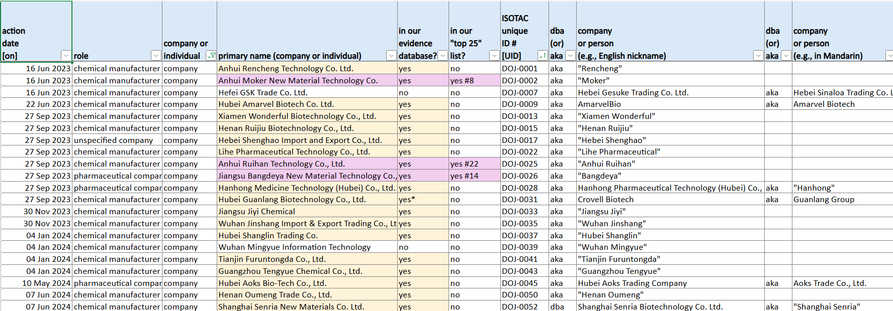

**Figure 1: USDOJ fentanyl precursor chemical manufacturing indictments data set**

**Dataset-2: Fentanyl precursors**

This dataset contains information on chemical substances used in fentanyl production. It lists CAS Registry Numbers (unique chemical identifiers), substance names, synonyms, and weight classifications for various fentanyl precursors. The dataset helps track key chemicals involved in illicit fentanyl manufacturing and their alternative names, making it useful for law enforcement and regulatory agencies.

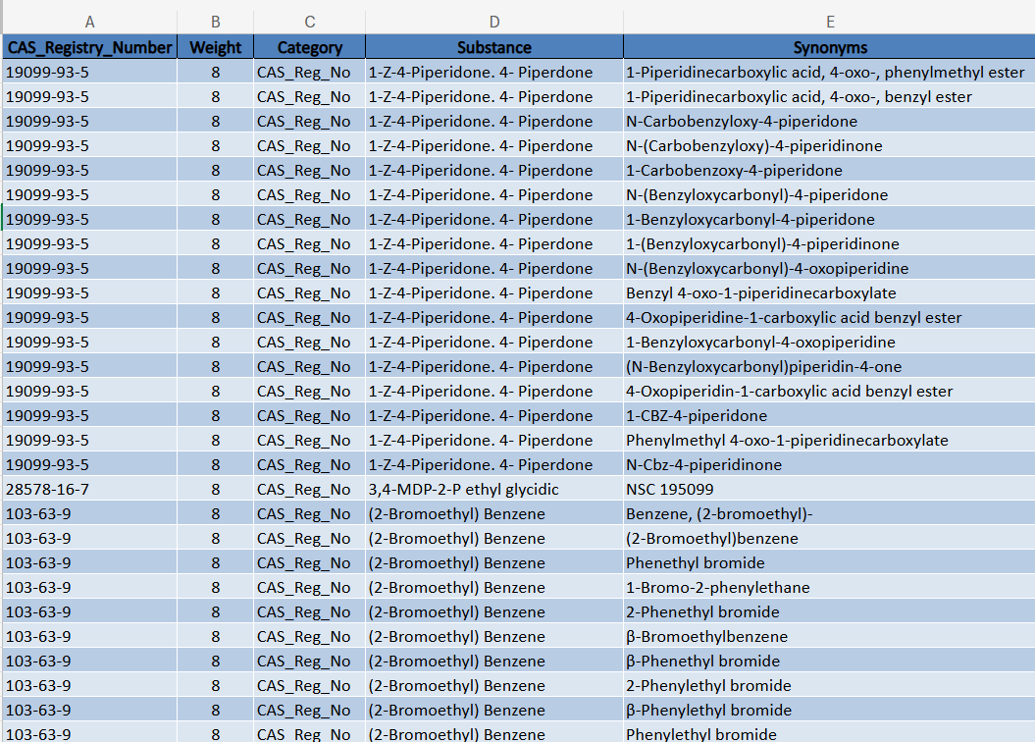

**Figure 2: Fentanyl precursors data set**

**Dataset-3: Integrated Data and Evidence Collection (Company Reference Sheet)**

This dataset contains a list of companies involved in the production and trade of chemical substances, many of which are related to the fentanyl supply chain. It documents company names, aliases, operational status (active/inactive), team assignments, and associated risk indicators. Some companies are flagged as "PRC-Funded Hits", suggesting potential government connections. Others are categorized as suspected fentanyl precursor suppliers based on previous investigations.

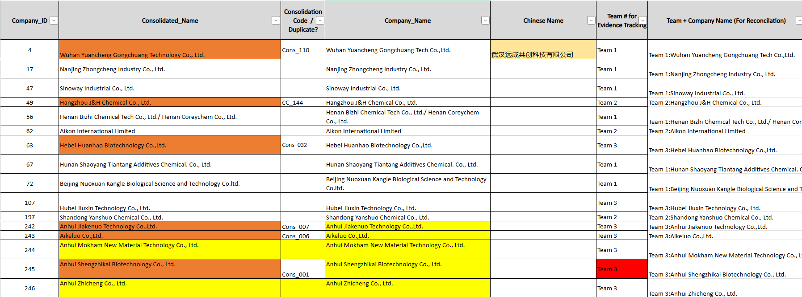

**Figure 3: Integrated Data and Evidence Collection (Company Reference Sheet) Data set**

## Field Descriptions

The following are the field descriptions for the datasets we have chosen

**Dataset-1: USDOJ fentanyl precursor chemical manufacturing indictments**

This section describes the fields in the dataset related to **USDOJ fentanyl precursor chemical manufacturing indictments**. Each field is crucial for tracking indicted companies and individuals involved in illicit activities.

1. **Press Release Date (Type: DateTime)** - The official date when the U.S. Department of Justice (USDOJ) publicly announced the indictment. This field follows the **DD MMM YYYY** format (e.g., "23 Jun 2023"). It helps establish the timeline of enforcement actions.
2. **Press Release URL (Type: string)** - The web address linking to the official USDOJ press release. This URL allows users to access the full details of the indictment. Each URL corresponds to a unique indictment and should not be duplicated in the database.
3. **USDOJ Action (Type: string)** - The legal action taken by the U.S. Department of Justice against the entity. The most common value in this field is **"indictment"**, indicating criminal charges filed.
4. **U.S. District (Type: string)** - The judicial district handling the case (e.g., **EDNY** for the Eastern District of New York, **MDFL** for the Middle District of Florida). This helps identify where the legal proceedings are taking place.
5. **Criminal Case Number (Type: string)** - The official case reference number assigned by the court (e.g., **23-CR-263**). This unique identifier ensures the traceability of court proceedings and related documents.
6. **Action Date (Type: Date Time)** - The specific date on which legal action was taken. This is distinct from the **Press Release Date** and indicates when the indictment was formally issued.
7. **Company Role (Type: string)** - Describes the involvement of the indicted entity. The primary role in this dataset is **"chemical manufacturer"**, which refers to companies engaged in producing fentanyl precursor chemicals.
8. **Company or Individual (Type: string)** - Indicates whether the indicted entity is a **company** or an **individual**. Most records in this dataset pertain to companies.
9. **Primary Name (Type: string)** - The official name of the indicted company or individual (e.g., **Anhui Rencheng Technology Co. Ltd.**). This is the main identifier used in legal documentation.
10. **In Evidence Database (Type: Boolean)** - Indicates whether the entity is included in an official law enforcement evidence database. Values are either **"yes"** or **"no"**.
11. **Top 25 List Inclusion (Type: string)** - Specifies whether the entity is among the **"Top 25"** most critical targets for enforcement. If included, this field displays its ranking (e.g., **“8"**). Otherwise, it is marked as **"no"**.
12. **Unique ISOTAC ID (Type: string)** - A tracking identifier assigned to each indicted entity (e.g., **DOJ-0001**). This ID ensures consistency in referencing companies across multiple records and legal documents.
13. **Aliases / DBA (Doing Business As) (Type: string)** - Alternative names used by the indicted company, including English nicknames. For example, **"Anhui Rencheng Technology Co. Ltd."** is also known as **"Rencheng"**. Multiple aliases are concatenated with a comma. **Dataset-2: Fentanyl precursors**

This section describes the dataset fields related to chemical substances and their registry information. Each field is essential

**Dataset-3: Integrated Data and Evidence Collection (Company Reference Sheet)**

This section describes the fields in the dataset related to **Integrated Data and Evidence Collection (Company Reference Sheet).** Based on columns **L to Q** in your dataset, here is a structured description of these fields:

**Dataset Fields Description (Columns L to Q)**

1. **Special Alert** **(Type: string)** - Flags specific alerts related to a company. It includes identifiers like "SA: PRC Funded Hit" and "SA: T3," indicating different categories of alerts based on predefined criteria.
2. **Company Evidence Count** **(Type: integer)** - Represents the number of evidence points associated with a company. A higher count suggests a stronger case or more supporting data regarding the company’s status.
3. **Company Evidence Weight (Type: integer)** - A weighted score assigned to the collected evidence for a company. This weight helps in assessing the significance of the evidence.
4. **Flagged by Matt/Andy** (Type: integer) - A binary indicator (0 or 1) showing whether a company has been flagged by specific individuals (Matt/Andy) for review or further analysis.
5. **Sanctioned Company** **(Type: integer)** - Indicates whether the company is under sanctions. A value of 1 means the company is sanctioned, while 0 means it is not.
6. **On Leads List** **(Type: integer)** - A binary indicator (0 or 1) showing if the company appears on a specific leads list, potentially for further monitoring or investigation.
7. **Special Alert (Duplicate Column)** **(Type: integer)** - This column appears to be a duplicate of "Special Alert," possibly used for different filtering or categorization purposes.
8. **Total Company Weight** **(Type: integer)** - Represents the final computed weight assigned to a company based on various factors such as evidence weight, special alerts, and flagged status.

## Data Context

**USDOJ fentanyl precursor**

• The USDOJ fentanyl precursor chemical manufacturing indictments dataset captures indictments and legal actions taken against companies and individuals suspected of producing and distributing fentanyl precursor chemicals.

• It includes press release dates, U.S. district court case numbers, company aliases, and geographic locations of these entities.

• The presence of “PRC Associations” and government-backed entities suggests that some companies operate with state involvement or indirect government support.

• This dataset is significant because it highlights the legal response to fentanyl precursor distribution and serves as a primary source for identifying high-risk entities.

**Fentanyl Precursors Expanded**

• The Fentanyl Precursors Expanded dataset catalogs chemical substances, their CAS numbers, synonyms, and classifications, providing insight into the specific ingredients used in illicit fentanyl synthesis.

• This data is essential in tracking supply chain movements, detecting illicit shipments, and monitoring precursor sales in international markets.

• Understanding the chemical context allows law enforcement and regulatory agencies to flag suspicious transactions, regulate exports, and disrupt illicit manufacturing.

• This dataset is particularly relevant when cross-referenced with company data, as it helps identify businesses that stockpile or distribute these precursor chemicals.

**Integrated Data and Evidence Collection (Company Reference Sheet)**

• The Integrated Data and Evidence Collection dataset provides a structured database of companies linked to fentanyl production.

• It integrates findings from multiple investigative teams, categorizing companies by:

* Active vs. inactive status (e.g., revoked licenses, name changes, or companies under investigation).
* Corporate aliases and rebranding tactics, which companies use to evade detection.
* Direct links to PRC funding or government-backed initiatives.

• Contextually, this dataset is crucial for understanding business operations, tracking entity relationships, and identifying new corporate structures formed after regulatory crackdowns.

## Data Conditioning

As part of our project, we have not performed any data conditioning or cleaning on the data. The datasets USDOJ fentanyl precursor chemical manufacturing indictments, Fentanyl precursors, and Integrated Data and Evidence Collection (Company Reference Sheet) have been used as they were provided, without any modifications or preprocessing. This means the data may still contain inconsistencies, missing values, or duplications that could impact analysis accuracy.

As we collect evidence, we may encounter empty values in the Integrated Data and Evidence Collection dataset, particularly in company records and operational status details. The remaining datasets, USDOJ fentanyl precursor chemical manufacturing indictments and Fentanyl precursors are clean as of our knowledge, with structured chemical identifiers and legal case references appearing consistent.

We may implement validation checks, standardization techniques, and entity resolution strategies in later stages to ensure optimal data quality. These steps will help refine our datasets, improve analytical accuracy, and enhance the reliability of findings drawn from the data. project, we have not performed any data conditioning or cleaning methods. The datasets USDOJ fentanyl precursor chemical manufacturing indictments, Fentanyl precursors, and Integrated Data and Evidence Collection (Company Reference Sheet) have been used as they were provided, without any modifications or preprocessing. This means the data may still contain inconsistencies, missing values, or duplications that could impact analysis accuracy.

As we collect evidence, we may encounter empty values in the Integrated Data and Evidence Collection dataset, particularly in company records and operational status details. The remaining datasets, USDOJ fentanyl precursor chemical manufacturing indictments and Fentanyl precursors are clean as of our knowledge, with structured chemical identifiers and legal case references appearing consistent.

We may implement validation checks, standardization techniques, and entity resolution strategies in later stages to ensure optimal data quality. These steps will help refine our datasets, improve analytical accuracy, and enhance the reliability of findings drawn from the data.

## Data Quality Assessment

The following are the data quality assessments of the datasets we have chosen

**Dataset: USDOJ fentanyl precursor chemical manufacturing indictments**

This dataset, sourced from the U.S. Department of Justice, contains records of companies and individuals indicted for manufacturing fentanyl precursors. It is employed for risk assessment and legal tracking.

* **Completeness:**
* The dataset covers key details like indictments, company names, aliases, locations, and fentanyl precursor confirmations.
* However, some fields, like "executive or employee of primary company", have a lot of "N/A" values, which might indicate missing or unavailable data.
* Most of the important data is present, but some fields may need further verification.
* **Consistency:**
* The dataset is well-organized, but some variations in formatting exist.
* For example, company aliases are sometimes labeled as "aka" or "dba", which could be confusing.Some dates and descriptive notes are formatted differently, making it harder to ensure consistency.
* While mostly consistent, formatting needs to be standardized for clarity.
* **Uniqueness:**
* Each company is assigned a unique ISOTAC UID, which helps keep track of them accurately.
* However, some companies appear multiple times under different aliases, which might create duplicate-looking records.
* The data is unique overall, but handling aliases properly would reduce redundancy.
* **Integrity:**
* The dataset is built from official legal records, law enforcement reports, and USDOJ indictments, ensuring credibility.
* However, some company locations differ between press releases and indictment records, which might need verification.
* The dataset is reliable, but cross-checking location data and aliases would improve trustworthiness.
* **Conformity:**
* The dataset follows a structured format, but some columns use inconsistent labels (e.g., multiple ways of noting aliases).
* Some notes include extra details that might need to be structured better, rather than written in free text.
* Most of the dataset conforms to expectations, but minor formatting cleanups are needed.
* **Accuracy:**
* Since the dataset is based on government and legal sources, it is highly accurate.
* However, minor errors may exist due to inconsistent location data and potential duplicate entries under different aliases.
* Accuracy is strong, but a review of company names and locations would help eliminate small discrepancies.

**Dataset: Fentanyl Precursors**

This dataset documents various fentanyl precursor chemicals, their sources, and supply chain patterns. It helps in locating dangerous substances and organizations engaged in the manufacture of illegal drugs.

* **Completeness:**
* The dataset is almost complete with only 9 missing values in the Synonyms column and no missing values in other columns.
* Overall, the dataset is well-structured and does not have significant gaps.
* **Consistency:**
* The dataset has no empty rows or columns, which ensures structural consistency.
* However, 70 duplicate rows exist due to multiple synonyms for the same substance, which may need standardization. Mostly consistent, but duplicates should be addressed.
* **Uniqueness:**
* The CAS Registry Number serves as a unique identifier ensuring that each chemical entry is traceable.
* However, duplicate entries caused by different synonyms reduce uniqueness.
* Uniqueness is strong at the substance level but needs refinement in synonym handling.
* **Integrity:**
* The dataset maintains structural integrity, but duplicate rows across all columns (70 entries) need verification.
* The Weight column ranges from 4 to 10, suggesting controlled values, but potential validation is required.
* Integrity is generally solid but requires minor cleaning.
* **Conformity:**
* The dataset follows a structured format with properly categorized fields, ensuring conformity.
* All columns align with expected data types, and the use of CAS Registry Numbers ensures industry standard compliance.
* No major issues, but some synonym variations may require standardization.
* **Accuracy:**
* The dataset is believed to be mostly accurate, with proper chemical classification and validated sources.
* Minor verification of duplicate entries and synonym mapping may improve accuracy.

**Dataset:** **Integrated Data and Evidence Collection (Working Copy)**

This dataset is owned by TraCCC, and compiles evidence on fentanyl precursor suppliers, including indictments, sanctions, and risk factors. It is gathered through structured data integrations, open sources, and investigations.

* **Completeness:**
* Company Evidence Count and Company Evidence Weight are well-populated (263 filled rows).
* Other columns (Flagged by Matt/Andy, Sanctioned Company List, On Leads List) contain mostly zeros or a few values, making them appear complete but not necessarily useful.
* The Special Alert column contains some missing (N/A) values, requiring further review.
* Overall, while the data is present, it needs further validation to ensure meaningful completeness.
* **Consistency:**
* Due to incomplete data, it is difficult to assess consistency.
* Some columns contain only zeros, which may indicate missing data rather than true values.
* Special Alert has inconsistent values (e.g., 500, 100, 0, #N/A), which may require standardization. Overall, consistency is unclear and needs cleaning.
* **Uniqueness:**
* The Company Evidence Count and Company Evidence Weight columns show 153 and 574 unique values, respectively, which suggests a broad range of data.
* Values range from 1 to 831 (Company Evidence Count) and 0 to 68,139 (Company Evidence Weight), indicating some variation but potential outliers.
* Other columns have very few unique values (e.g., 0, 150, 10), which limits their usefulness.
* **Integrity:**
* The data appears structured but lacks clear validation rules, especially for flagged or sanctioned companies.
* Zero-filled columns may not be meaningful, suggesting that additional checks are needed to confirm accuracy.
* Integrity is questionable, requiring verification with source data.
* **Conformity:**
* The dataset follows a structured format, but the presence of #N/A values and inconsistent entries suggests the need for standardization.
* Special Alert values (500, 100, 0, N/A) lack clear categorization, requiring normalization.
* Column definitions need to be clarified to ensure correct interpretation.
* **Accuracy:**
* Company Evidence Count and Weight seem reliable based on their unique values and range.
* Other columns have low variability (mostly zeros), which may suggest missing or incorrect data rather than accurate reporting.
* Special Alert column needs cleaning, as #N/A values indicate missing information. Overall, data accuracy needs improvement through validation and correction.

## Other Data Sources

For this project, we have exclusively used the provided datasets:

* USDOJ Fentanyl Precursor Chemical Manufacturing Indictments
* Fentanyl Precursors
* Integrated Data and Evidence Collection (Company Reference Sheet)

No additional external data sources were considered or incorporated into our analysis. These datasets were deemed sufficient for our research objectives, providing comprehensive information on fentanyl precursor chemicals, related actions, and entities involved in the supply chain.

## Data sets created

The data architecture of the ISO Determination Engine is anchored in two interrelated systems: the Weight Tagging Mechanism and the Key-Value Logging System. These structures were developed to manage the complexity of evidence intake, risk evaluation, and traceable tagging of companies and chemical substances. Each dataset within these systems serves a unique function to ensure policy alignment, data normalization, and analytical scalability.

## Weight Tagging Mechanism

The weight tagging system enables the structured application of risk scores to various entities. It consists of six core sheets, each handling a different layer of the tagging hierarchy or assignment logic.

**1. Weighting Tag Type**

This sheet defines the type of entity a tag is associated with company, substance, or evidence. This ensures that tags are applied to appropriate entities, maintaining the integrity of the scoring system.

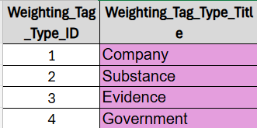

**Figure 4: Weighting Tag Type**

**2. Weighting Tag Category**

Each tag type is further refined into categories such as Sanctions and Indictments, DEA CSA Schedules, Government Subsidies, or Historical classifications. This layer allows logical grouping for risk analysis.  
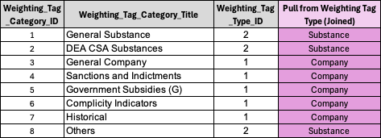

**Figure 5: Weighting Tag Category**

**3. Weighting Tag**

This sheet defines the individual tags, including their titles, descriptions, and assigned weight values. It is the central reference for how scoring is conducted and allows for continuous adjustment of risk indicators.  
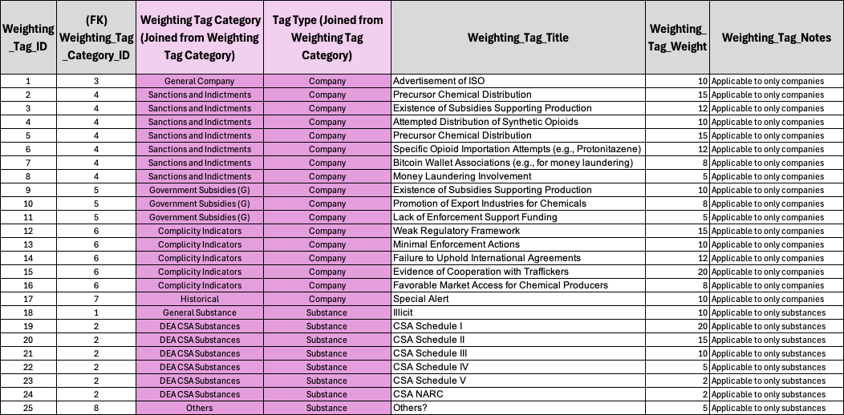

**Figure 6: Weighting Tag**

**4. Company Weighting Tag**

This sheet stores all tag assignments to companies. Each record includes a reference to the tag and the company, enabling aggregation of risk scores from multiple tags per company. And the pivot below store weigthing rolled up to comapines .

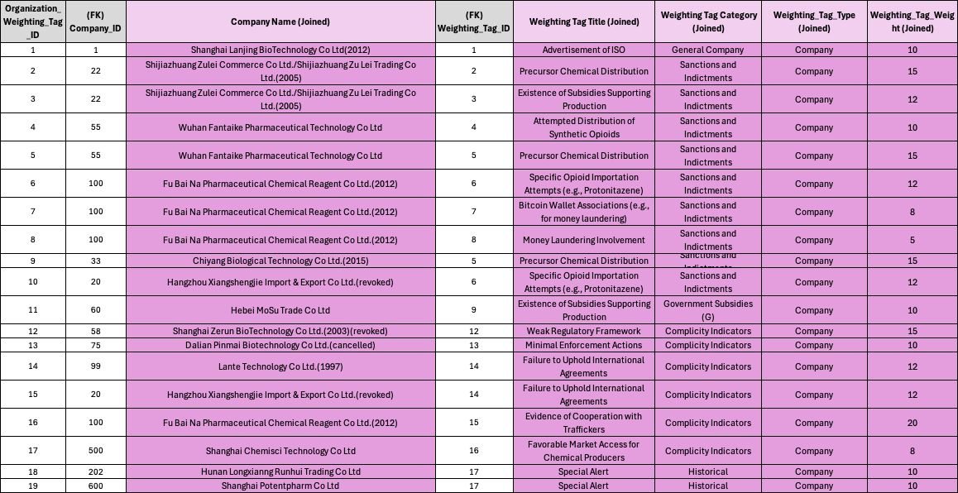

**Figure 7: Company Weighting Tag**

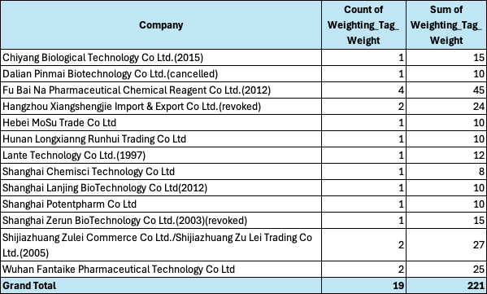

**Figure 8: Weighting Rolled Up to Companies**

**5. Substance Weighting Tag**

Like the company sheet, this stores tag assignments for chemical substances. Each substance can be linked to multiple tags, with cumulative scores calculated for prioritization. And the pivot below store weigthing rolled up to subsatances.

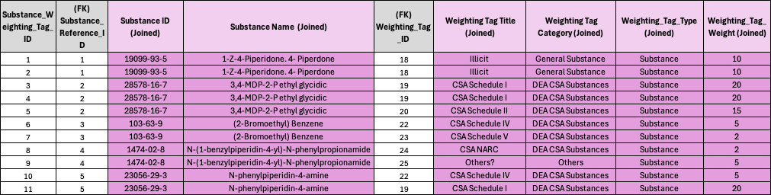

**Figure 9: Substance Weighting Tag**

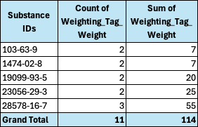

**Figure 10: Weighting Rolled Up to Substances**

**6. Evidence Weighting Tag**

This sheet links tags directly to documents or evidence items, allowing for a verifiable connection between extracted content and assigned risk values. It also enables direct traceability from scoring to source material.And the pivot below store weigthing rolled up to evidence.

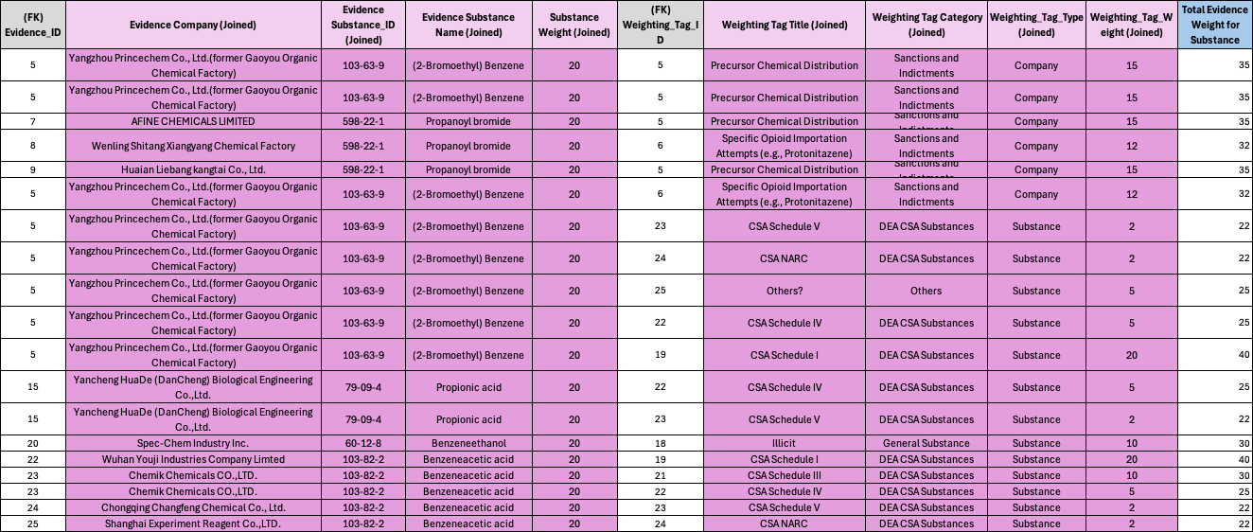

**Figure 11: Evidence Weighting Tag**

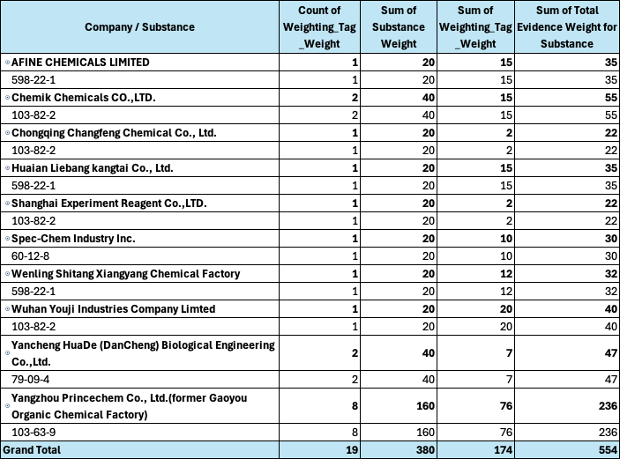  
**Figure 12: Weighting Rolled Up to Evidence**

## Key-Value Logging System

## This system is designed to track and structure evidence as it enters the intake pipeline. It ensures all data is normalized, traceable, and linked to its source object.

**1. Object Log**

Each document or evidence source is stored as an object with a unique ID, type, and status. This sheet anchors the entire evidence processing pipeline and supports document tracking, processing status, and provenance.  
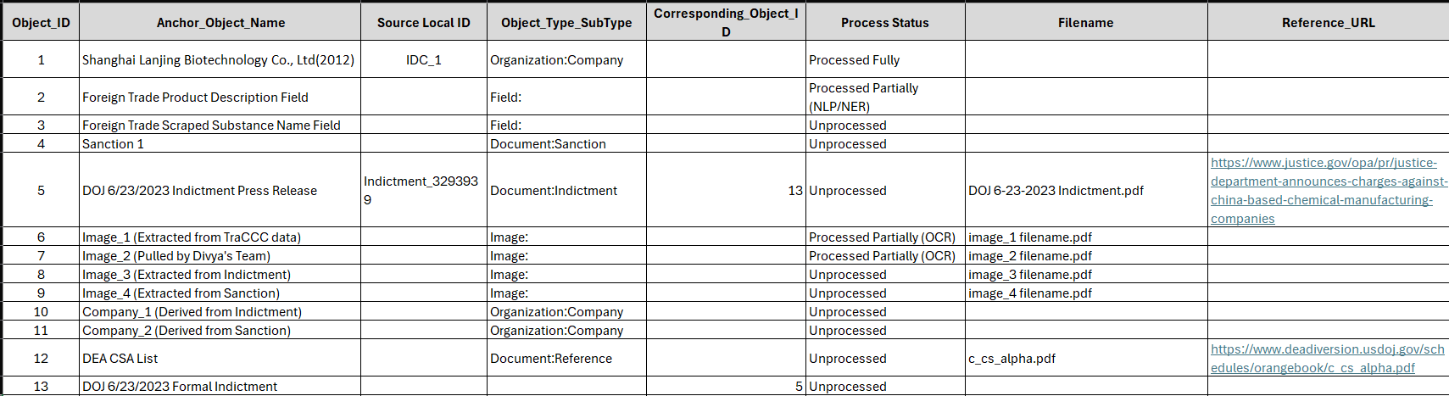

**Figure 13: Object log**

**2. Attribute Log**

Attributes represent specific fields extracted from documents, such as names, case numbers, or dates. These are linked back to the object log and normalized using a controlled vocabulary for consistency.

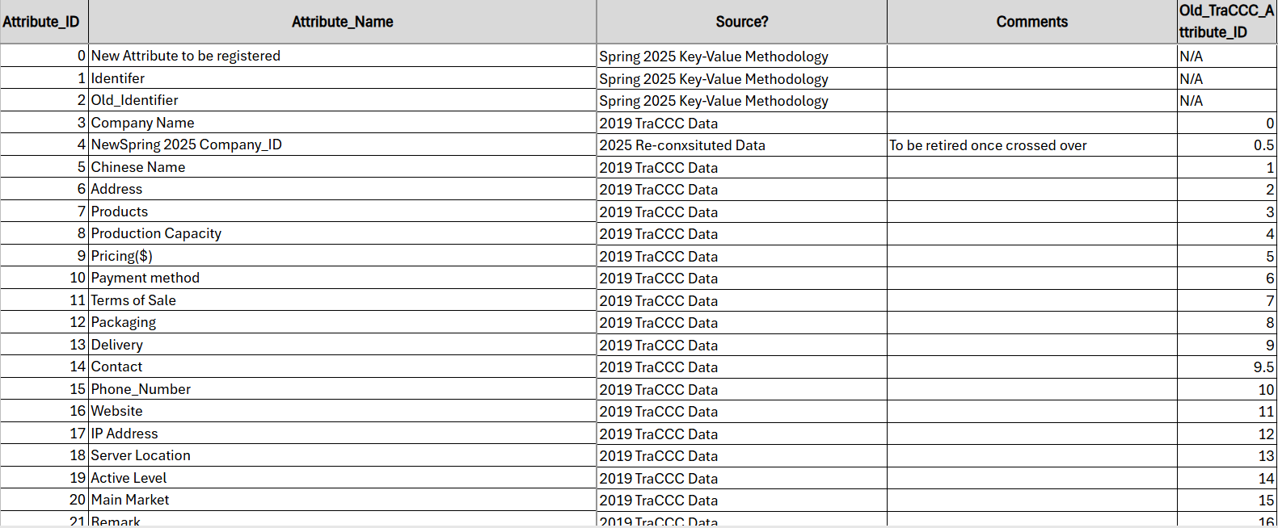

**Figure 14: Attribute log**

**3. Data Log**

The data log is the final structured output that brings together objects and their attributes into an analyzable form. It is the core table used for scoring, traceability, and intake processing outcomes.  
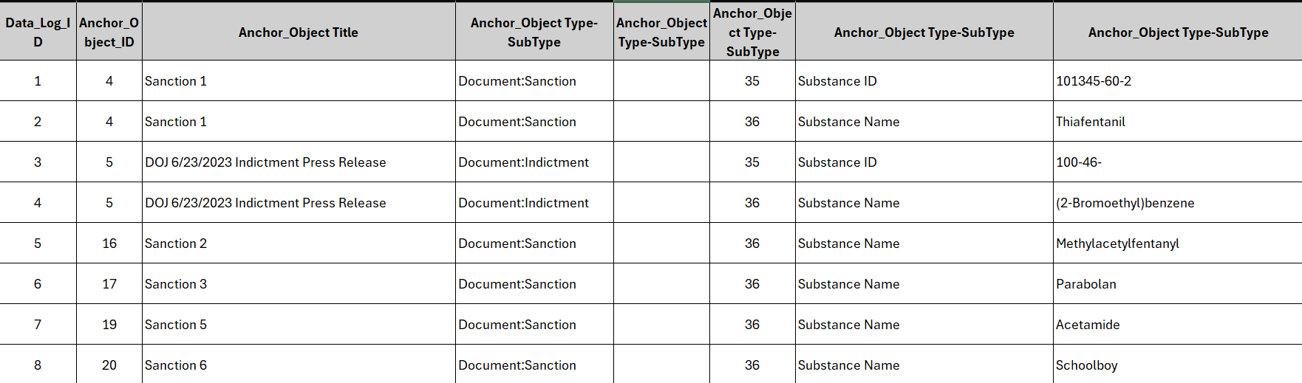

**Figure 15: Data log**

Together, the Weight Tagging Mechanism and Key-Value Logging System ensure robust risk assignment and evidence tracking. These structured datasets offer scalability, traceability, and analytical accuracy, positioning the ISO Determination Engine as a reliable framework for evaluating threats associated with synthetic opioids.

## Storage Medium

For our project, we utilized the Microsoft ecosystem, leveraging Excel for data analysis and Teams for collaborative storage. This choice was driven by its ease of use, familiarity, and built-in features that supported efficient project management.

* **Microsoft Excel** served as our primary tool for data storage and analysis. Its robust functionalities enabled us to organize, filter, and process large datasets efficiently. Excel also provided a secure and structured repository for our datasets, reinforcing data integrity throughout the project.
* **Microsoft Teams** played a crucial role in facilitating seamless collaboration. With its centralized platform, our team could easily share files, discuss analyses, and stay updated on project developments in real time. The integration with Excel further streamlined our workflow, allowing for instant access and review of shared spreadsheets. This continuous feedback loop significantly improved our data analysis processes.

By combining these tools, we not only enhanced productivity but also ensured that our data remained secure, organized, and readily accessible, adapting to the dynamic needs of our project.

## Storage Security

Data security was a top priority throughout our project, supported by the resources available through George Mason University. We implemented stringent security measures across Microsoft Teams, and Outlook to safeguard sensitive information.

* **Microsoft Teams**: We maintained the confidentiality of our communications and shared data by enabling end-to-end encryption for chats and file sharing. Advanced permission settings ensured that only team members with specific roles could access sensitive information, further minimizing security risks.
* **Microsoft Outlook**: As our primary communication tool, Outlook’s advanced security features including malware filtering and phishing protection safeguarded email transmissions, meeting invitations, and other official correspondence. With the seamless integration of Outlook and Teams, coordinated by George Mason University’s IT services, we ensured secure and efficient project communication.

By implementing these security measures, we upheld high standards of data protection, ensuring compliance while minimizing potential risks to our project’s integrity.

## 3.10Storage Costs

Managing storage costs effectively was essential to maintaining the security infrastructure of our project. With the support of George Mason University, we were able to optimize resource allocation while keeping expenses under control.

* **Microsoft Licenses**: The university’s support significantly reduced the costs associated with Microsoft Excel, Teams, and Outlook, allowing us to benefit from their built-in security features without additional financial strain.
* **Operational Costs**: Daily expenses included maintaining security protocols, training team members on best security practices, and ensuring the secure integration of our communication tools. These costs were regularly assessed for efficiency and affordability, with George Mason University offering financial and technical support to help us achieve our security objectives.

By combining cutting-edge security solutions with strategic budget management, we ensured our project remained both financially viable and secure, aligning with our commitment to data protection and operational efficiency.

# Investigation and Exploration

## Solution Approach

This section details our investigative approach, covering our system architecture, security measures, and data flow. We emphasize data-driven evidence extraction and risk assessment for fentanyl-related crimes, leveraging machine learning and The ISO Determination Engine is designed as a structured, semi-automated system that collects, processes, and evaluates evidence to identify illicit synthetic opioid (ISO) activity. The workflow begins with evidence collection, where analysts monitor global sanctions, indictments, legal policies, and other relevant events. These events are logged as "Intake Objects," with associated attributes stored in a "Registered Attribute Log." Evidence is then extracted, anchored to specific intake objects, and compiled into an "Intake Data Log" for further analysis. From this evidence, substances and companies are processed separately. The system allows ISO Chemical Mappers to maintain and enrich substance data, including CAS numbers, synonyms, historical records, and registry sources. Substances are tagged using predefined "Substance Weighting Tags" such as CSA Schedules or indicators of illicit use. Similarly, companies are tagged with "Company Weighting Tags" based on activities like advertising ISO products or involvement in precursor chemical distribution. Both tagging systems are supported by a central Weighting Factor module, which houses tag categories, descriptions, and numerical weights used in scoring. These scores are accumulated and analyzed to assess risk, trigger alerts, and support enforcement prioritization. Evidence deconfliction, provenance tracking, and scenario-based analysis enhance the system's accuracy and transparency. The entire process is governed by flexible CRUD interfaces for tags, references, and analytics rules, allowing ISO Determiners to continuously refine the criteria and improve detection efficacy.

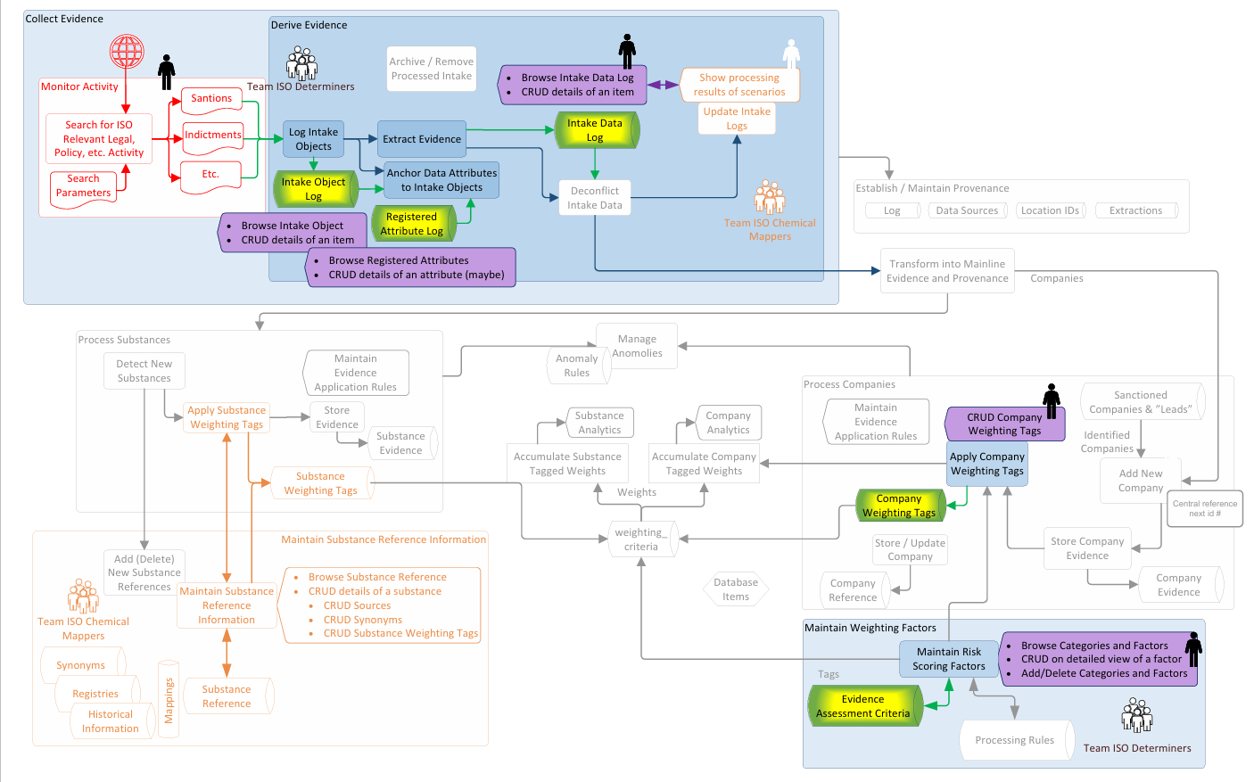

**Figure 16: Solution Schematic**

### Systems Architecture

Our system is a multi-component intelligence framework that operates through:

* **Evidence Collection:** Gathering data from legal records, law enforcement logs, and external intelligence sources.
* **Data Processing & Attribution:** Converting raw text and evidence logs into structured, actionable information.
* **Risk Assessment & Prioritization:** Leveraging weighting algorithms and machine learning models to evaluate and rank threat levels.
* **Decision Support:** Producing actionable intelligence reports to aid in decision-making.

### **Architectural Layers of Our System:**

* **Data Ingestion Layer:** Aggregates raw data from sanctions, indictments, reports, and ISO-relevant policies.
* **Preprocessing and NLP Pipeline**
* Named Entity Recognition (NER) identifies chemical, and company mentions.
* Dependency parsing extracts context around relationships.
* **Database Layer:** Stores structured attributes, intake objects, and evidence logs for retrieval and analysis.
* **Analysis Layer:** Models assess, score, and rank cases to determine priority levels.

**Integration of weighting factors:**

A crucial part of the architecture is the **weighted risk scoring engine**, located downstream from the evidence classification. This module uses the following **weighted formula** to compute an overall risk score:

Total risk Score=(S×w1​) +(G×w2​) +(C×w3​)

Where:

* S, G, C = Raw sub-scores derived from matched evidence.

The weights used:

* w1​=1.2 (Sanctions)
* w2​=1.1 (Government Subsidies)
* w3​=1.3 (Complicity Indicators)

These **weighting factors** reflect our prioritization of risk: we consider **complicity** the most critical signal, followed by **sanctions**, and then **government subsidies**. Architecture supports dynamic adjustment of these weights based on future expert input or evolving policy needs.

#### **UI and decision support:**

The final component of the system is a **Streamlit-based interactive dashboard**, which presents ranked company profiles alongside the evidence and score breakdown. Analysts can explore why a particular company is flagged, trace back to the evidence, and even adjust weights in real-time to see how it impacts rankings.

In conclusion, the weighting factors are not merely applied at the end of the process but are deeply embedded in the **architecture’s logic**, serving as a tunable layer that influences final decision outcomes based on parameter importance. This design ensures flexibility, interpretability, and actionability for stakeholders combating synthetic opioid trafficking.

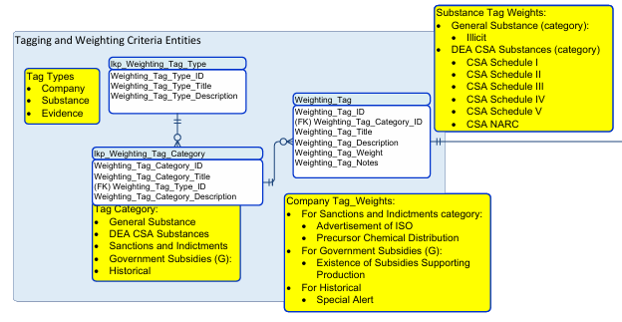

**Figure 17: System Architecture**

### Systems Security

Due to the sensitive nature of the data involved in detecting illicit synthetic opioid activity, maintaining strong system security was a top priority throughout the development. The team incorporated multiple safeguards to protect the system’s infrastructure, data storage, and user interactions. The following measures were implemented to ensure both internal operations and external access points were secure against unauthorized access and potential data breaches:

* **Secure local environments:** All development and data processing were carried out on secure local machines to limit exposure to raw or unfiltered data.
* **Private GitHub repository:** The project's code and documentation were maintained in a private GitHub repository, accessible only to authorized team members.
* **Controlled access:** Data and models were shared only through secure collaboration tools and cloud platforms with restricted access to prevent misuse.
* **No exposure of sensitive data:** The team ensured that all datasets used in the project were free from personally identifiable information and any confidential data related to law enforcement.

### Systems Data Flows

* **Raw Data Intake** → **Intake Object Log** → **Evidence Extraction** → **Data Mapping & Weighting** → **Risk Scoring** → **Final Intelligence Output**
* Data is **transformed** into a **human & machine-readable** format to maintain provenance.

## Running the Investigation

### Preparing Data and Evidence

To support and streamline our work, we developed an Evidence Tracking Sheet to monitor and document the full lifecycle of evidence collection, from initial identification to tagging and analysis. In parallel, we established a centralized evidence repository to securely store all collected materials, such as sanction records, indictments, and other relevant artifacts. Each piece of evidence was reviewed and categorized into structured data formats, enabling easier extraction and downstream processing. These categories aligned with our system architecture, such as substance-related data, company actions, and legal source metadata.

To ensure consistency and traceability, we used this categorized data to populate a Key-Value Sheet which is our “conditioned” or “working” format. This sheet serves as a well-organized, architecture-aligned tracking interface, mapping raw evidence to specific system attributes like substance reference entries, associated synonyms, tag weights, and company identifiers. This conditioning and prepping process involved transforming unstructured information into clean, linkable formats such as resolving duplicates and aligning with internal taxonomies.

Additionally, we performed several background tasks not immediately visible: we created logic for linking intake logs to registered attributes, cleaned conflicting or overlapping data (deconfliction), and cross-referenced sources with tagging rules to support future automation. By setting up these foundational formats and workflows, we established a consistent, scalable method for turning raw evidence into actionable, tagged intelligence within our ISO determination architecture

### Algorithms & Analysis Methodology

# The process of identifying and evaluating illicit synthetic opioid (ISO) activity begins with the creation of an Object Log, which serves as the central intake repository for all incoming evidence. This log captures raw, unstructured data entries from a variety of sources, including sanctions lists, indictments, regulatory filings, and law enforcement records. Each entry in the Object Log represents an intake object containing potentially relevant information about substances, companies, or individuals. Once an intake object is registered, the system initiates attribute extraction using data-driven identification techniques to isolate key entities such as company names, chemical substances, aliases, and related metadata. These extracted attributes are then standardized and structured based on a predefined schema aligned with the Intake Data Attributes Log, ensuring the data is normalized and prepared for further analysis. After extraction, the standardized attributes are cross-referenced with existing databases and verified legal intelligence sources to accurately link companies, substances, and aliases to their respective records. Through robust entity resolution techniques, the system minimizes duplication and enhances mapping accuracy, ensuring reliable integration with regulatory frameworks, enforcement records, and industry registries. The verified records are then stored in structured formats, supporting efficient risk analysis and case prioritization. Once the entities are successfully linked, both supervised and unsupervised machine learning models are applied to assess the risk associated with each. Historical data, behavioural patterns, and inter-entity relationships are analysed to identify suspicious activity. Algorithms such as K-means clustering help uncover hidden patterns and connections among substances, actors, and jurisdictions, enabling effective risk stratification. These models continuously improve by learning from new data and analyst feedback. Finally, the system synthesizes the extracted attributes, verified links, and model predictions to produce ranked risk assessments. These rankings are informed by weighted evidence scores, the severity and frequency of offenses, and corroborated intelligence sources. A statistical ranking framework is employed to prioritize cases, allowing law enforcement to focus resources on the most urgent and high-risk threats. This structured, data-driven output significantly enhances decision-making and supports timely, targeted enforcement interventions.

### Establishing and Maintaining Provenance

# **Each data entry is timestamped and traced** back to its source using a **provenance tracking system** that ensures data integrity. Every modification, update, or transformation is recorded in a data log, preserving the historical trail of evidence. This system enables analysts to verify the **origins, processing steps, and responsible entities** associated with each data point.

# **Transformations and updates are logged** for transparency, ensuring that every modification is tracked within a library log and object log. This logging process records all changes, including entity resolutions, and provenance updates, allowing for full traceability of data lineage.

### Accounting and Adjudicating Anomalies and Discoveries

* **Anomalies are flagged** during data intake and processing**.**
* **Investigators review flagged cases** to determine whether they indicate **data errors or new criminal patterns.**

### Exploring the Solution Instrumentation (or Tooling)

We opted for unsupervised learning methods because the data we’re dealing with is unstructured and constantly evolving, making predefined labels impractical. Since fentanyl trafficking is highly dynamic, traditional supervised approaches wouldn’t be effective. Instead, we used K-means clustering and other unsupervised algorithms to uncover hidden patterns in entity relationships and case linkages. These models help our system adapt in real-time as new data comes in, enhancing anomaly detection and risk assessment. Plus, unsupervised learning allows us to scale across massive, diverse datasets without the need for extensive manual labeling.

### Instrumentation Selection

**K-means clustering was selected** over other techniques because:

* It **groups similar cases without labeled training data**, making it ideal for identifying hidden patterns in unstructured forensic datasets.
* It handles **large, unstructured datasets efficiently**, enabling rapid classification and analysis of fentanyl-related intelligence.
* It supports **dynamic data adaptation**, allowing models to update and refine risk assessments as new evidence emerges.
* Its **clustering capabilities help reveal hidden networks**, exposing potential trafficking patterns and criminal associations that may not be immediately evident.

## Running the Instrumentation

### **Data model integration**: Establishing structured connections between legal and forensic evidence by linking datasets from law enforcement, legal records, and forensic reports. This approach facilitates seamless data interoperability, ensuring that intelligence sources can be effectively cross-referenced to enhance the accuracy and reliability of case evaluations.

### Artificial Intelligence

In the ISO Determination Engine, Artificial Intelligence (AI) played a crucial role in evidence extraction and improving data processing workflows. SecureGPT was specifically deployed to enhance the intake and normalization of sensitive enforcement data, such as indictments, sanctions, and regulatory documents.

SecureGPT’s contributions included:

* **Evidence Extraction**  
  SecureGPT parsed unstructured documents including DOJ press releases, OFAC sanction reports, and regulatory filings to identify key entities such as companies, individuals, and chemical names. It extracted attributes like case numbers, sanction reasons, and publication details without manual intervention, ensuring a consistent and reliable extraction process.
* **Structuring and Organizing Evidence**  
  SecureGPT categorized the extracted evidence by type (e.g., sanction, indictment, subsidy) and assigned preliminary risk tags based on detected keywords and contextual analysis. Extracted details were stored in a Key-Value Evidence Tracking System, along with metadata like publication dates and issuing authorities.
* **Secure Handling of Sensitive Information**  
  Given the sensitivity of the data, SecureGPT was operated within secure environments, using only public domain documents and ensuring no raw data was exposed to unsecured servers. This approach-maintained compliance with legal and ethical standards.
* **Improving Scalability and Accuracy**  
  SecureGPT enabled rapid integration of new evidence, reduced manual errors, and prepared the architecture for future full automation. It allowed the system to dynamically ingest new sanctions, indictments, and regulatory actions without redesigning parsing rules for every document type.

By implementing AI in the evidence intake pipeline, the ISO Determination Engine significantly enhanced its ability to process large volumes of complex legal information quickly, securely, and consistently.

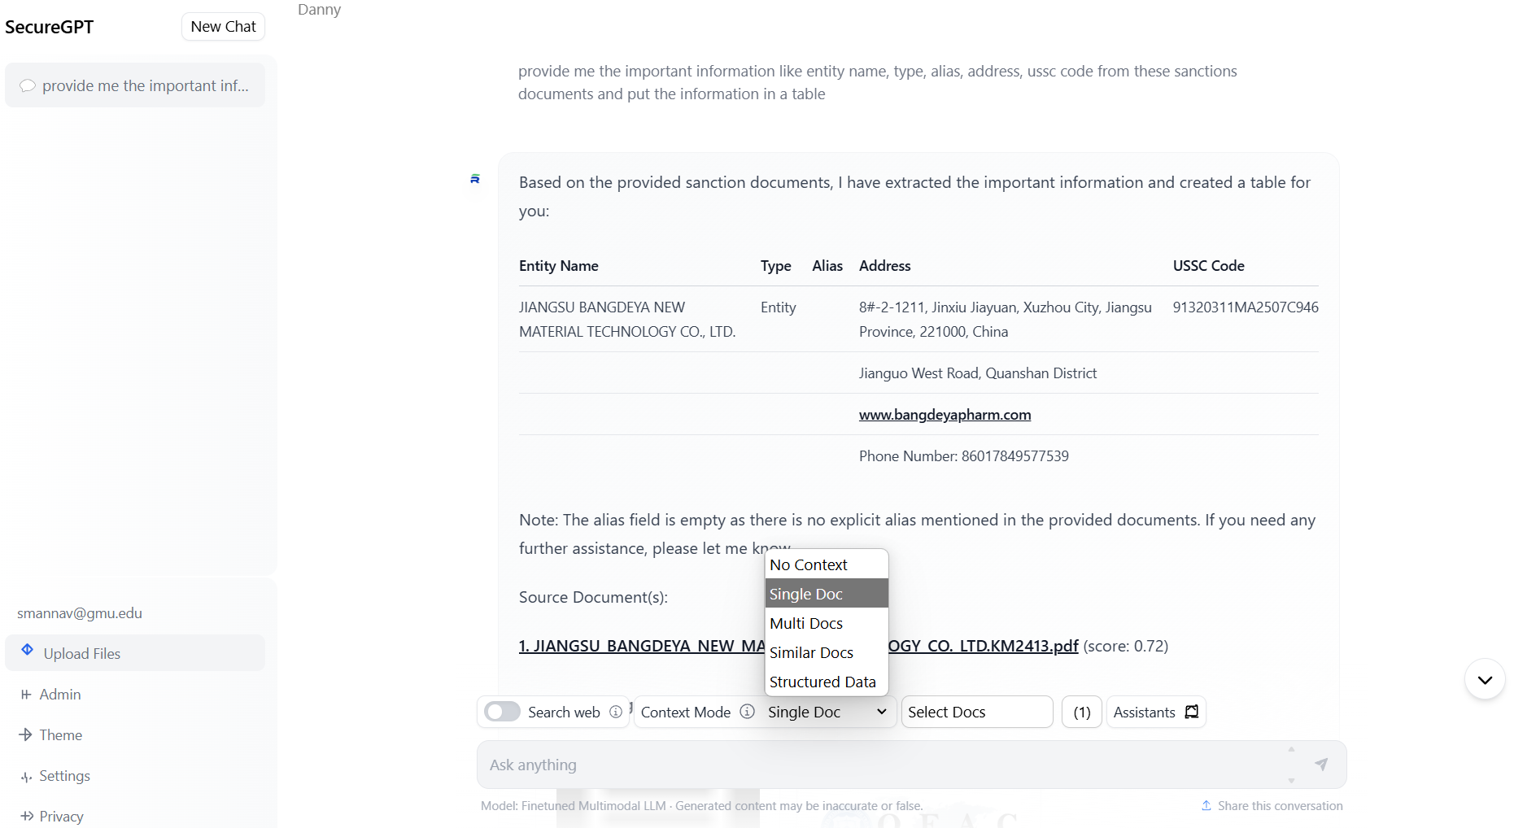

**Figure 18: Secure GPT Interface**

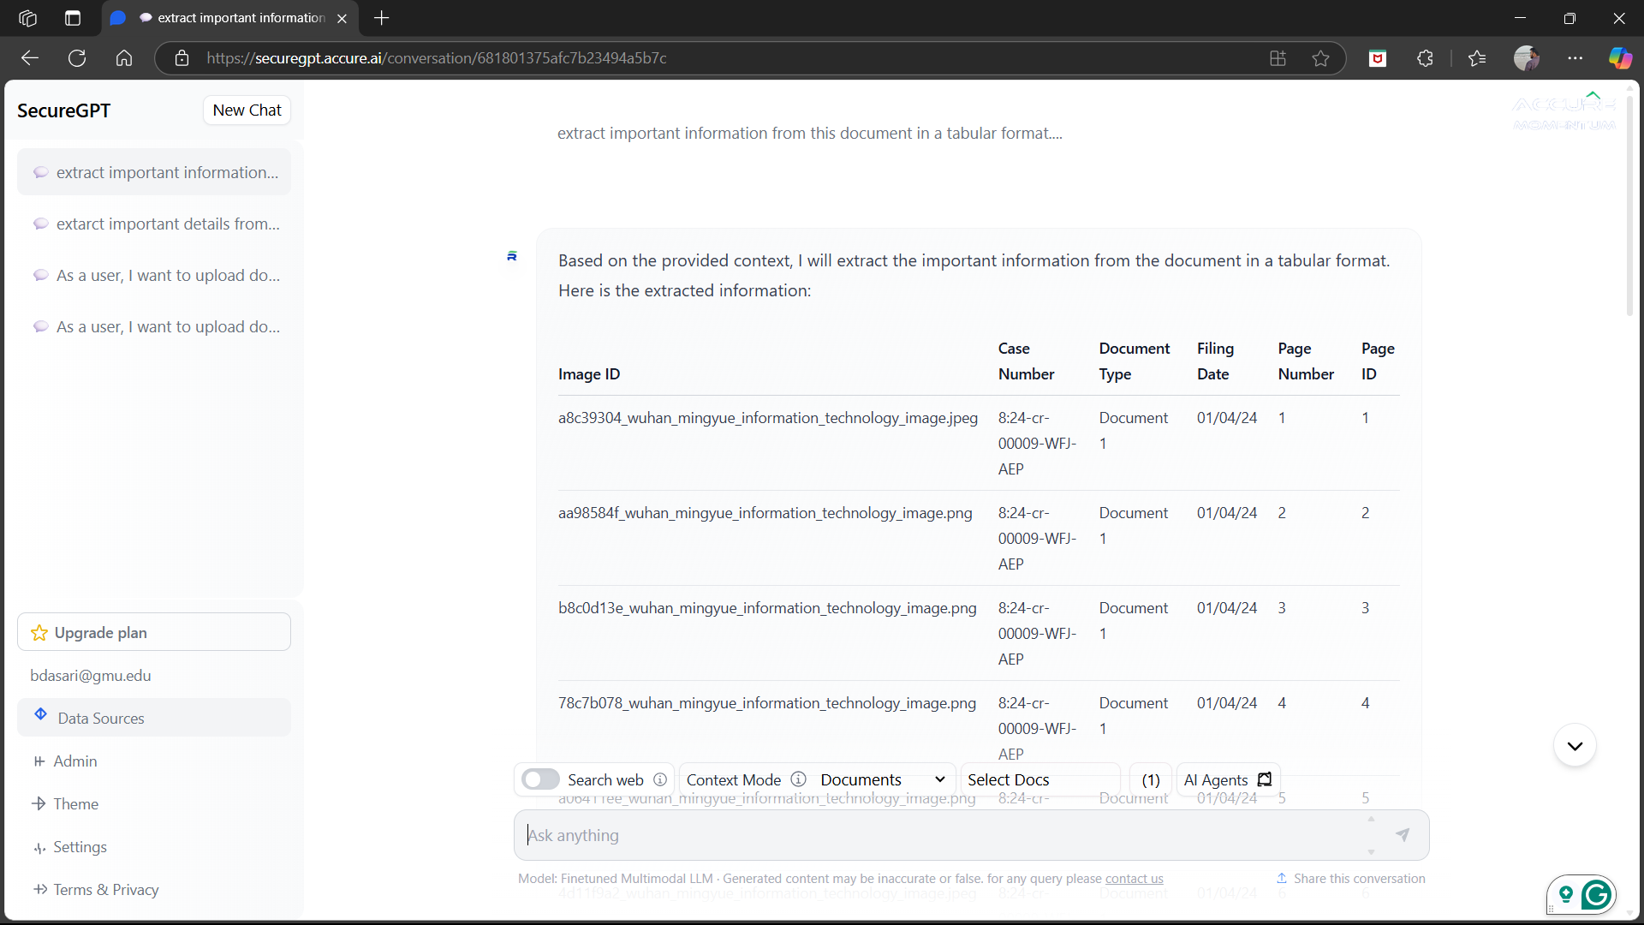

**Figure 19: Results Generated by Secure GPT**

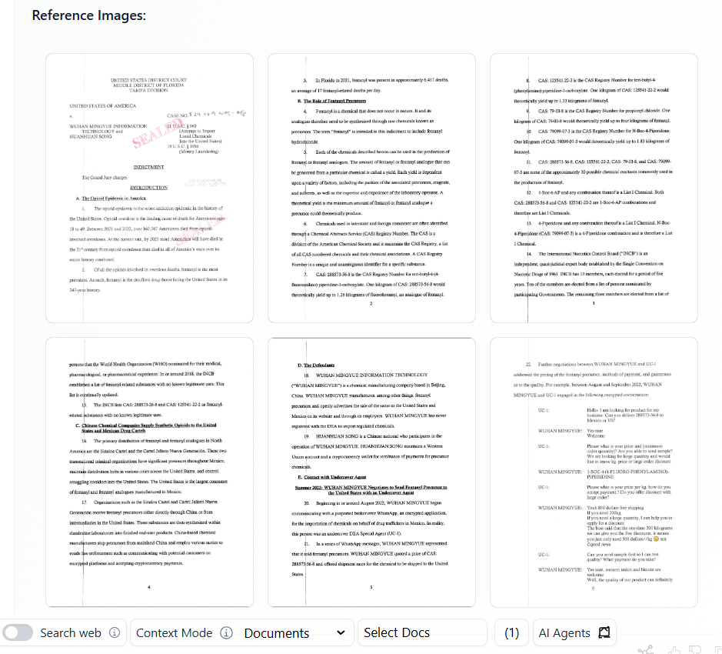

**Figure 20: Images Extracted by Secure GPT**

### Pulling It Together

After automating extraction and structuring with SecureGPT, the next critical step involved organizing and preparing the data for analysis and visualization.

The consolidation process involved several key actions:

* **Establishing a Common Evidence Format**  
  All extracted evidence was normalized into a consistent, structured format. This standardization ensured that regardless of the document source or type, critical attributes like entity names, case numbers, sanctions reasons, and publication metadata were consistently captured and organized.
* **Integrating the Data and Evidence**  
  The structured evidence was merged into a unified Key-Value Evidence Tracking System. This integration allowed seamless linking between extracted attributes, risk indicators, and source metadata, creating a fully traceable and auditable evidence repository.
* **Enabling Pivots and Filtering**  
  The structured evidence repository was designed to support pivoting and filtering operations. Users could dynamically group evidence by entity, event type, risk tag, or source authority. This flexibility greatly enhanced the system's analytical capabilities, enabling users to drill down or roll up evidence depending on investigative or policy needs.

Through this structured approach, the ISO Determination Engine transformed complex, unstructured enforcement data into an actionable, navigable evidence base ready for dynamic risk scoring, prioritization, and enforcement support.

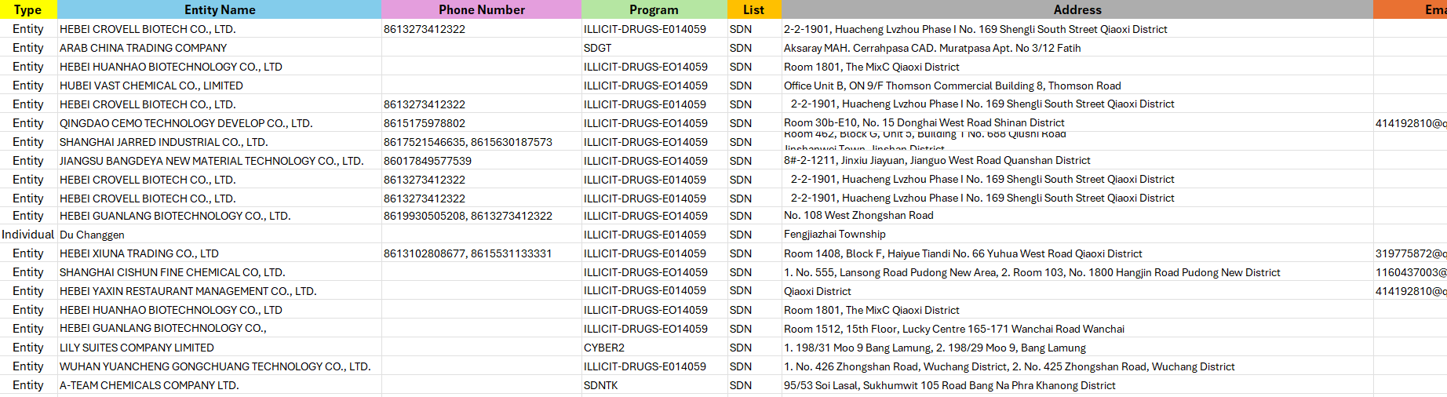

**Figure 21: Organized Data Generated by Secure GPT**

**4.4: User Interface**

**User Interface**

The user interface (UI) designed for the Illicit Synthetic Opioid (ISO) Determination Engine is structured to support two critical operational areas: the **tagging mechanism** and the **evidence logging and scoring system**. Together, these modules enable analysts, policy researchers, and enforcement officers to maintain, manage, and act on complex risk data surrounding synthetic opioids and the companies or substances involved in their production and distribution.

**Part 1: Tagging Mechanism – Managing Weighting Factors**

The first module of the UI is the **tagging mechanism**, which is responsible for the management of risk weighting factors and how they are assigned to substances, companies, or pieces of evidence. This interface was developed to be both user-friendly and robust, enabling full CRUD operations—Create, Read, Update, Delete, and Rename—across six foundational datasets. These datasets together form the basis of how risk is scored in our system, allowing for customizable weight values, metadata linking, and policy-aligned tag classifications.

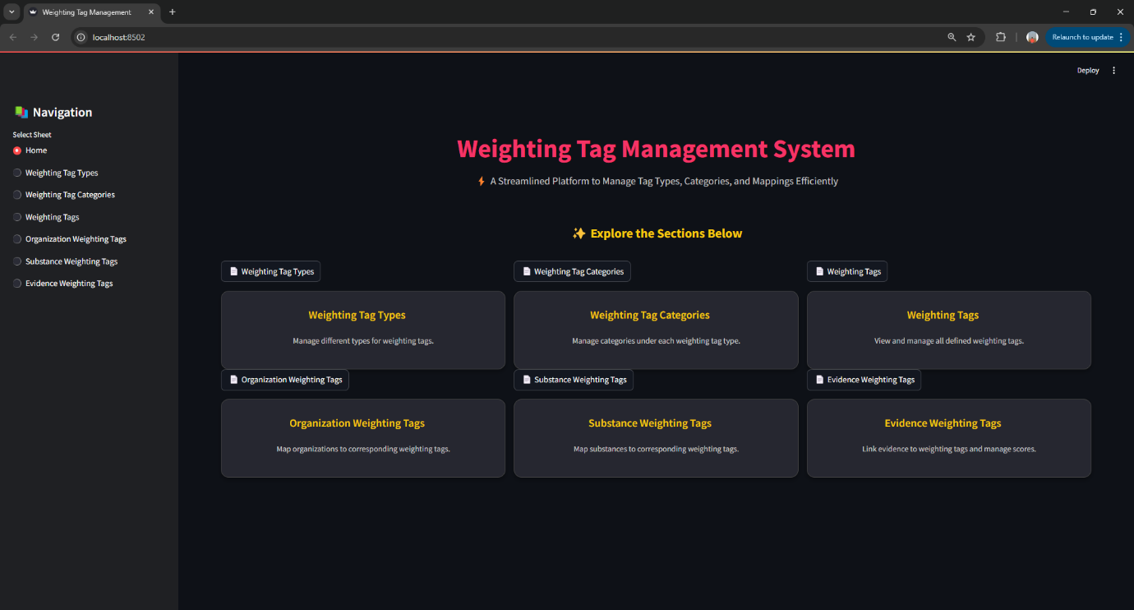

**Figure 22: Weighting Tag Management Homepage**

At the highest level, users interact with the **Weight Tag Types** sheet. This sheet defines broad risk groupings such as “Illicit”, “CSA Schedule”, or “DEA SSL”, each of which corresponds to different legal or regulatory classifications. These serve as the root categories for how evidence is grouped and interpreted.

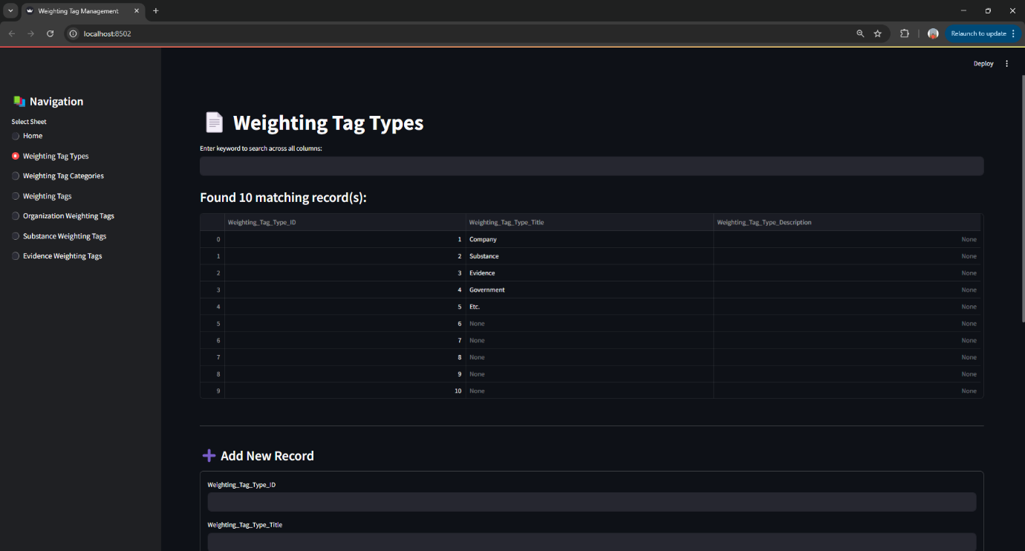

**Figure 23: Weighting Tag Type with CRUD Details**

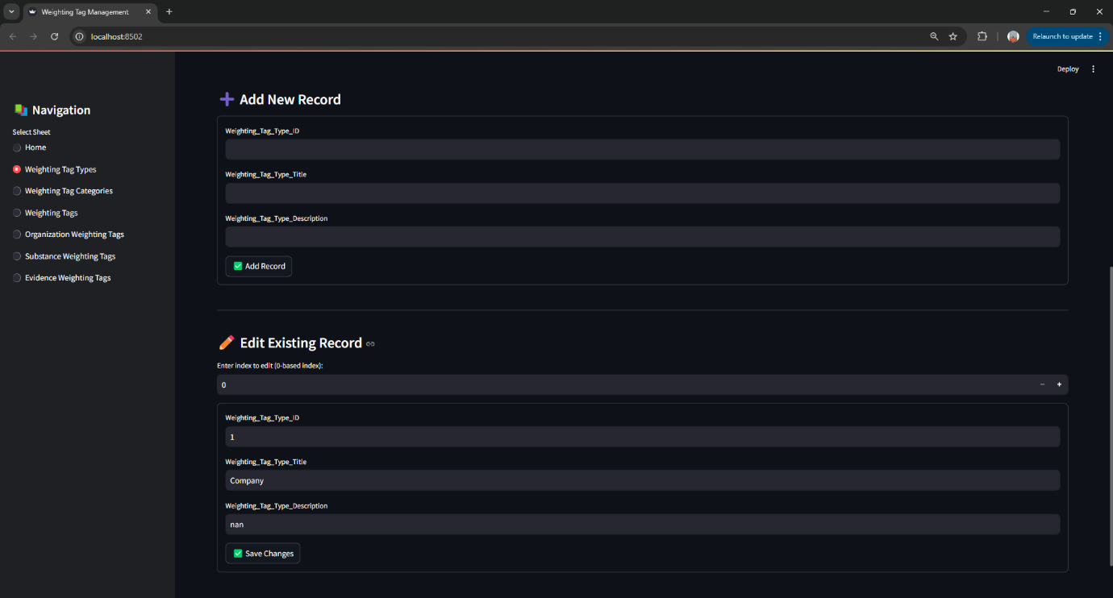

**Figure 24: Weighting Tag Type with CRUD Details**

From there, the **Weighting Tag Category** sheet offers a more refined classification structure. Within each type of tag, multiple categories may exist to separate enforcement-focused tags from registry metadata or domain-specific intelligence. These categories help structure the tag system in a scalable and logical format.

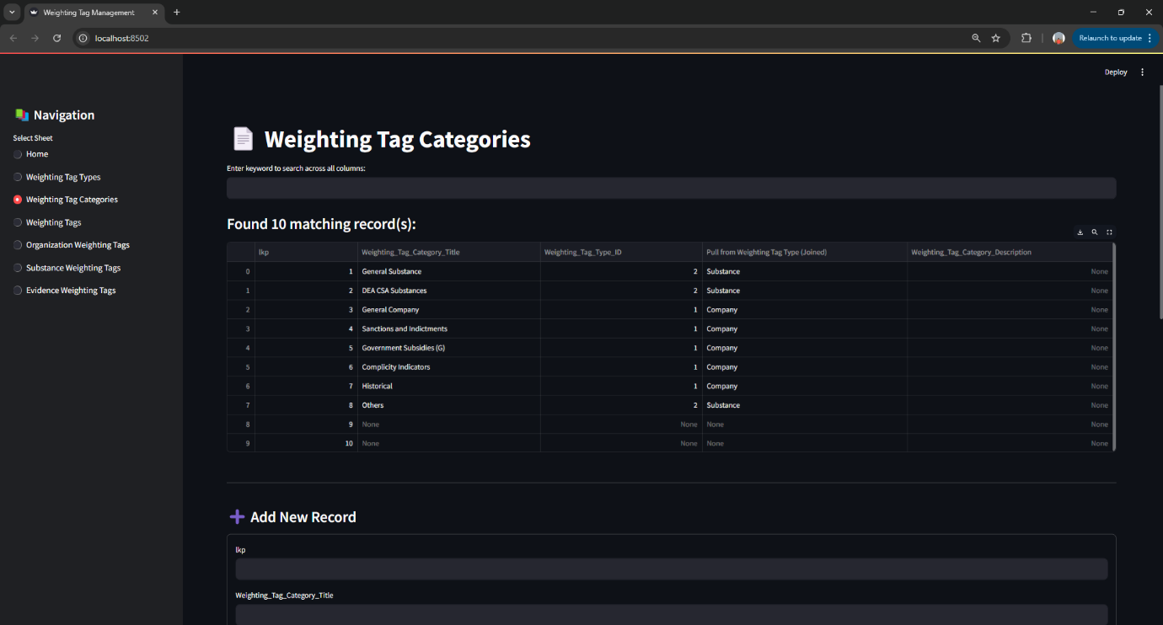

**Figure 25: Weighting Tag Category with CRUD Details**

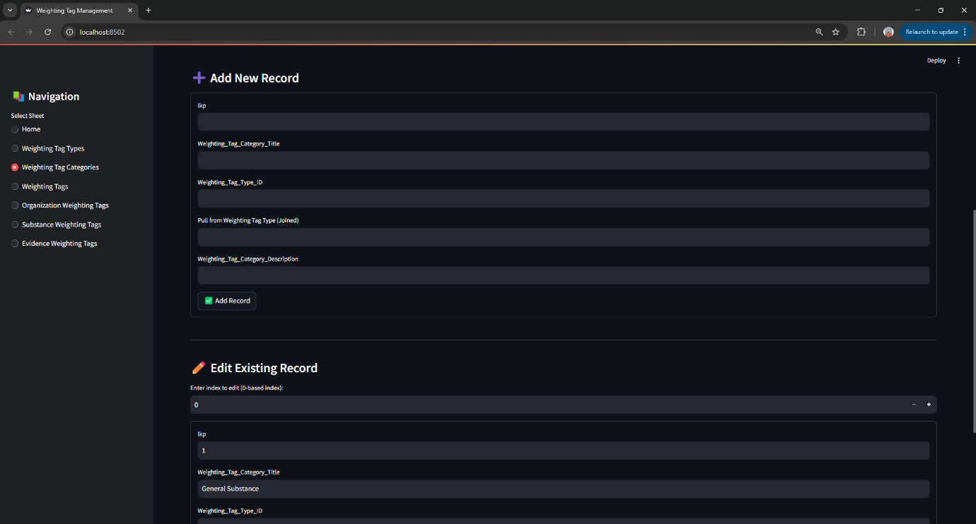

**Figure 26: Weighting Tag Category with CRUD Details**

Next, the **Weighting Tags** sheet is where individual tags are defined. Each tag has a unique title, a weight value, and a detailed description. This is the level where domain analysts can introduce new scoring criteria based on emerging threats or evolving policies. For example, if a new trafficking behavior is identified, a new tag with an appropriate weight can be created instantly through this interface.

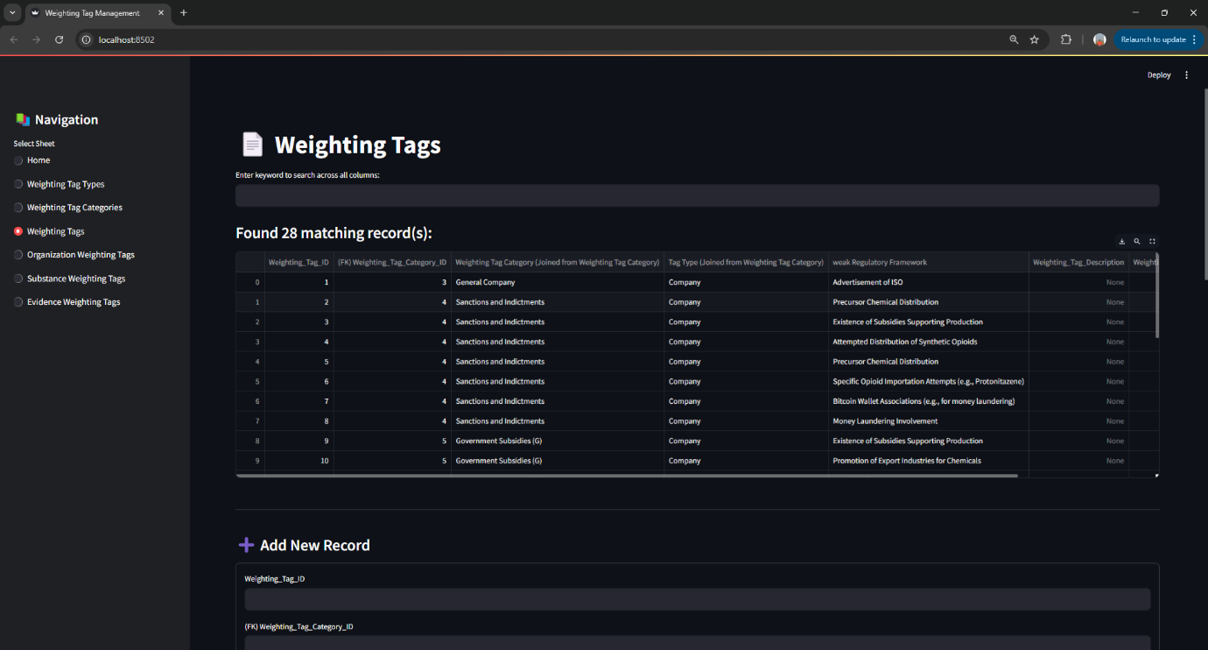

**Figure 27: Weighting Tags with CRUD Details**



**Figure 28: Weighting Tags with CRUD Details**

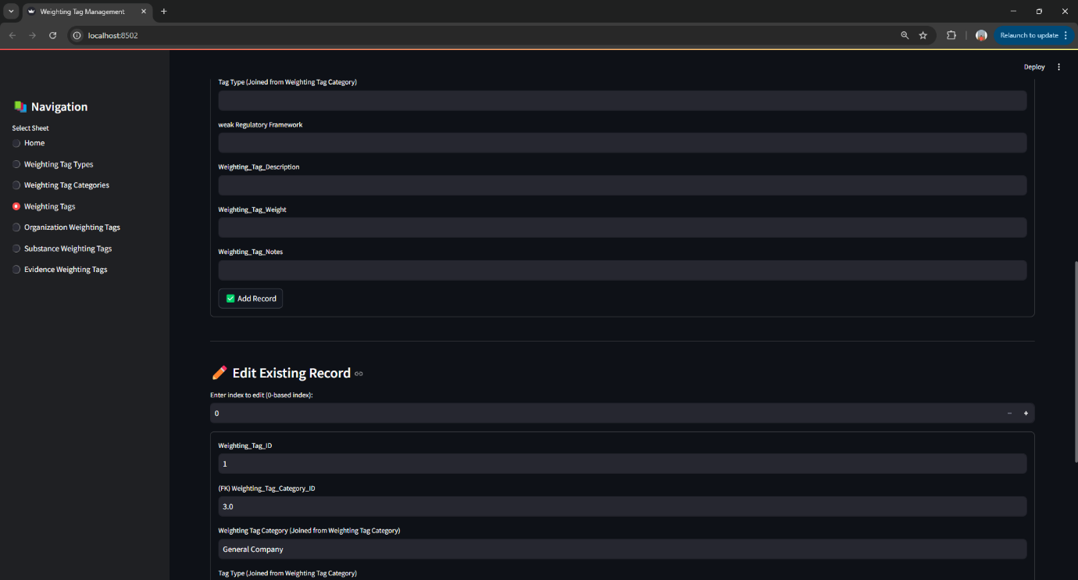

**Figure 29: Weighting Tags with CRUD Details**

The tagging system also includes direct assignment to **Substances**, **Companies**, and **Evidence**. The **Substance Weighting Tag** sheet allows for linking tags such as “Precursor Chemical” or “Illicit Analogue” to specific compounds. This is particularly useful in classifying fentanyl analogs or synthetic cannabinoids based on regulatory alerts or scientific findings.

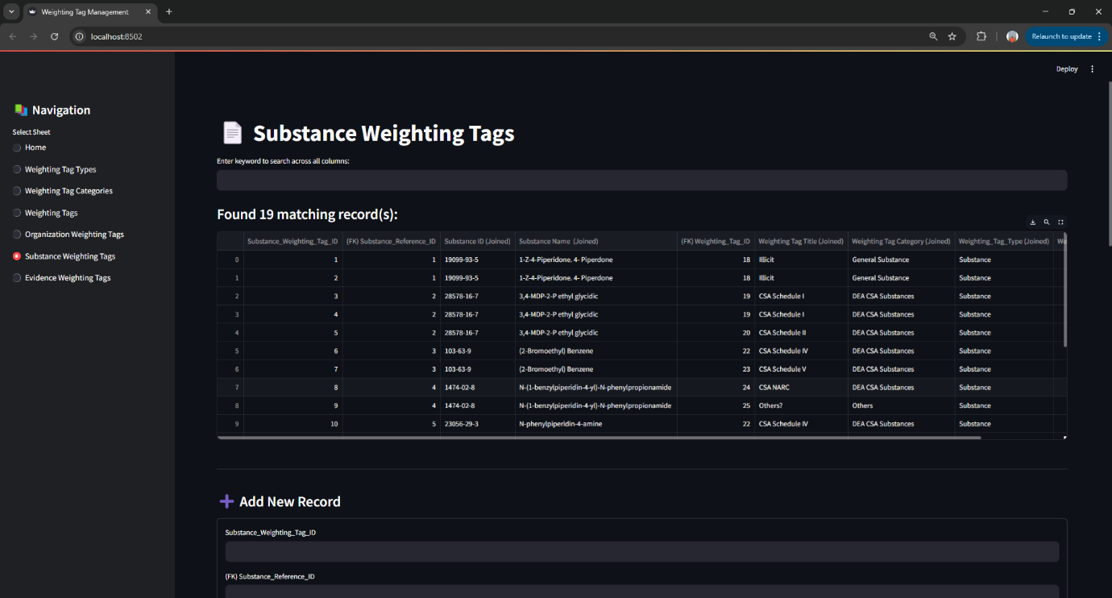

**Figure 30: Substance Weighting Tags with CRUD Details**

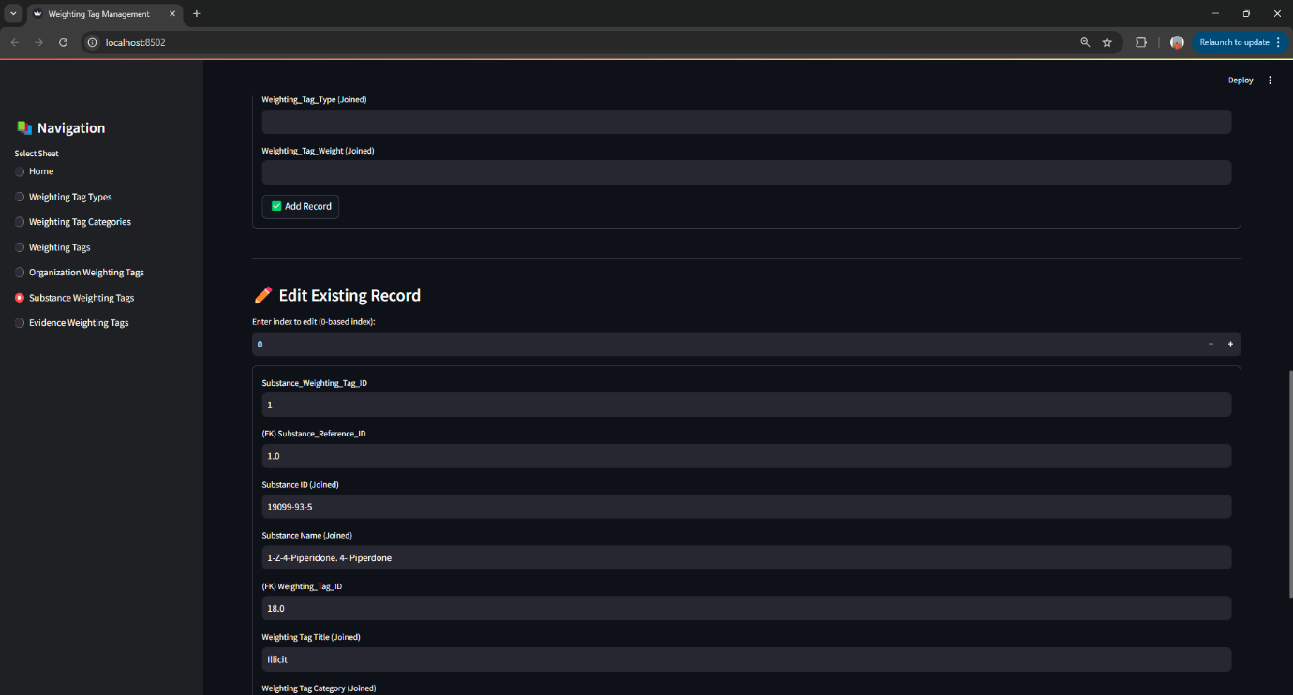

**Figure 31: Substance Weighting Tags with CRUD Details**

Similarly, the **Organization Weighting Tag** sheet enables enforcement agencies to link risk indicators such as sanctions, suspicious subsidies, or regulatory violations to specific companies. These tags are essential in helping generate automated company risk scores that feed into further prioritization models.

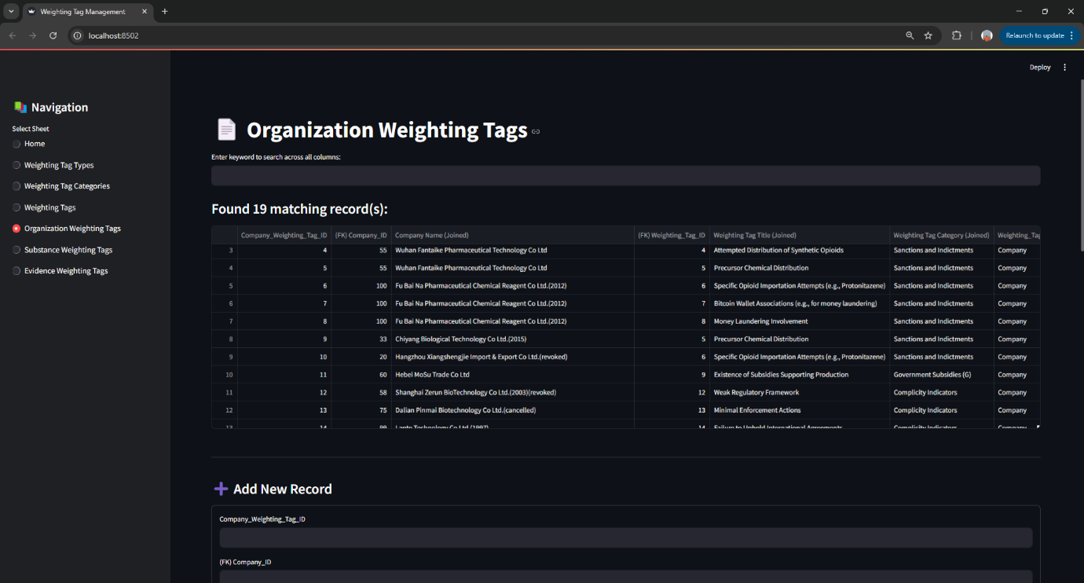

**Figure 32: Organization Weighting Tags with CRUD Details**

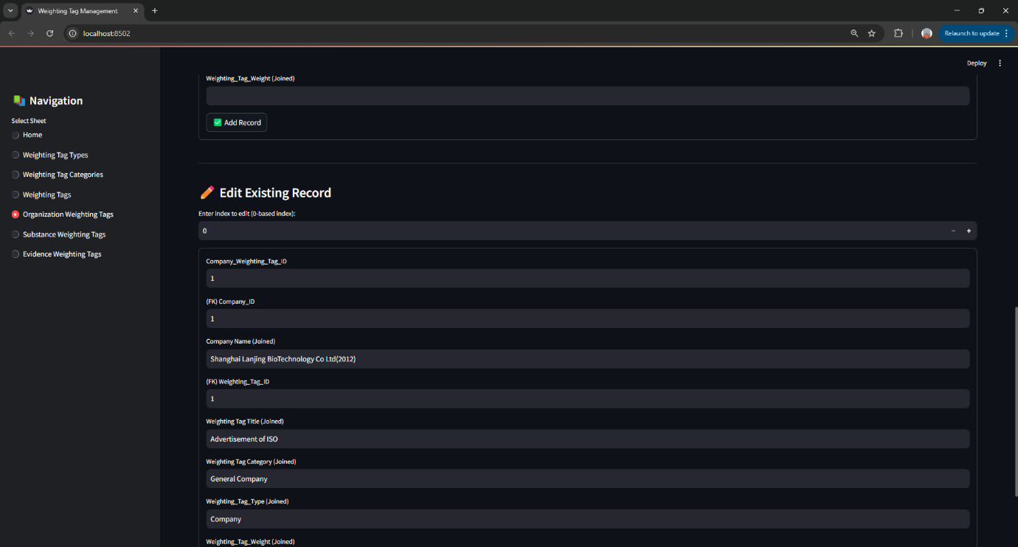

**Figure 33: Organization Weighting Tags with CRUD Details**

Finally, the **Evidence Weighting Tag** sheet ties tags directly to pieces of evidence like legal notices, press releases, or database entries. This linkage supports traceability and defensibility, ensuring that every weight applied has a verifiable source.

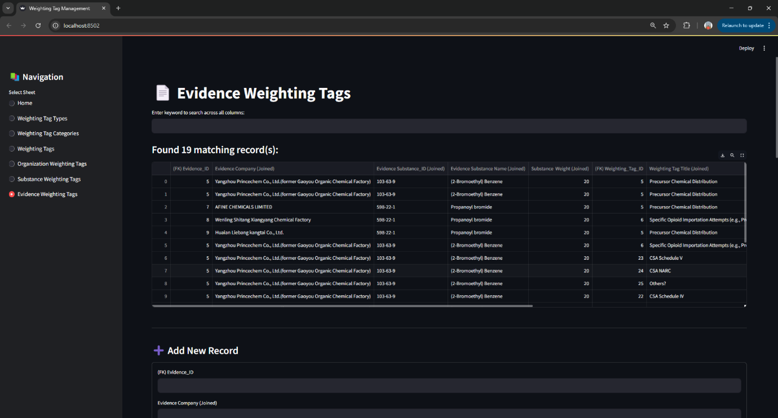

**Figure 34: Evidence Weighting Tags with CRUD Details**

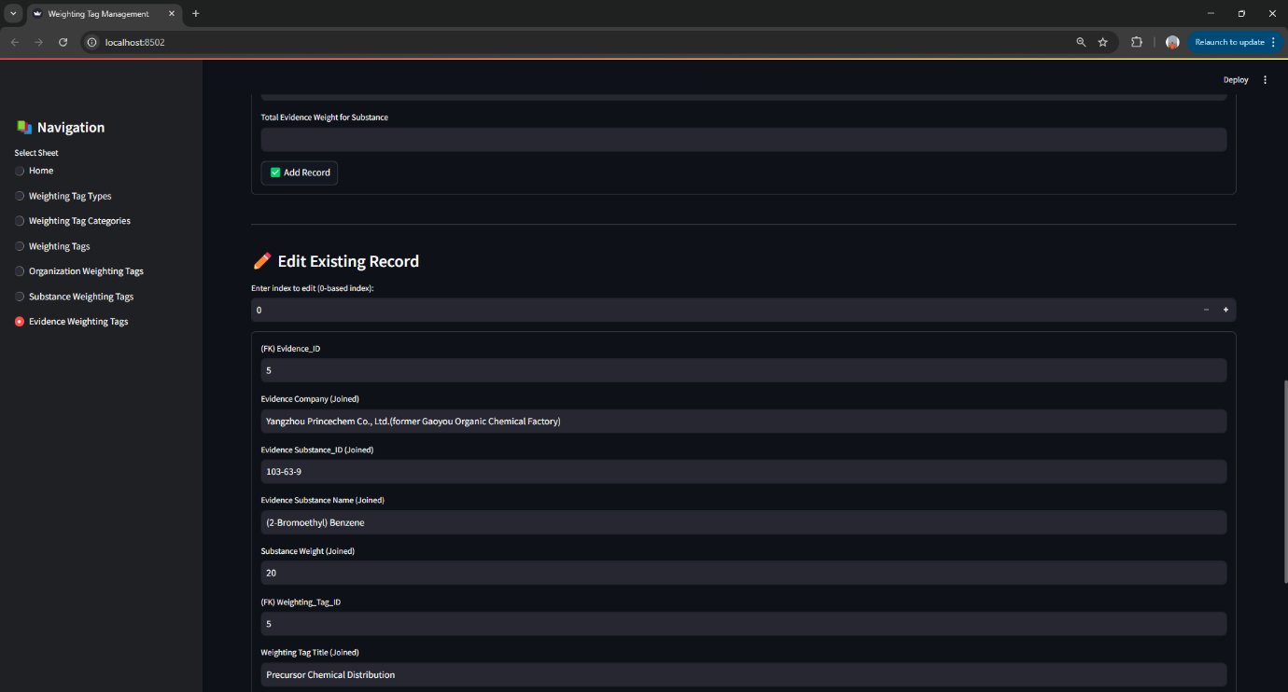

**Figure 35: Evidence Weighting Tags with CRUD Details**

This tagging mechanism reflects a highly modular and policy-aligned risk assignment system. Analysts can evolve scoring logic dynamically without needing backend changes, all from within the interface. The UI is also designed to be CRUD-ready in every sheet, ensuring it supports end-user flexibility as the model evolves.

**Part 2: Logging and Risk Scoring System**

The second module of our user interface is focused on managing incoming evidence and using that data to compute and interpret risk scores. This module contains structured **evidence logs**, a **risk scoring prototype**, and full CRUD operations to support analysts in tracking and evaluating entities over time.

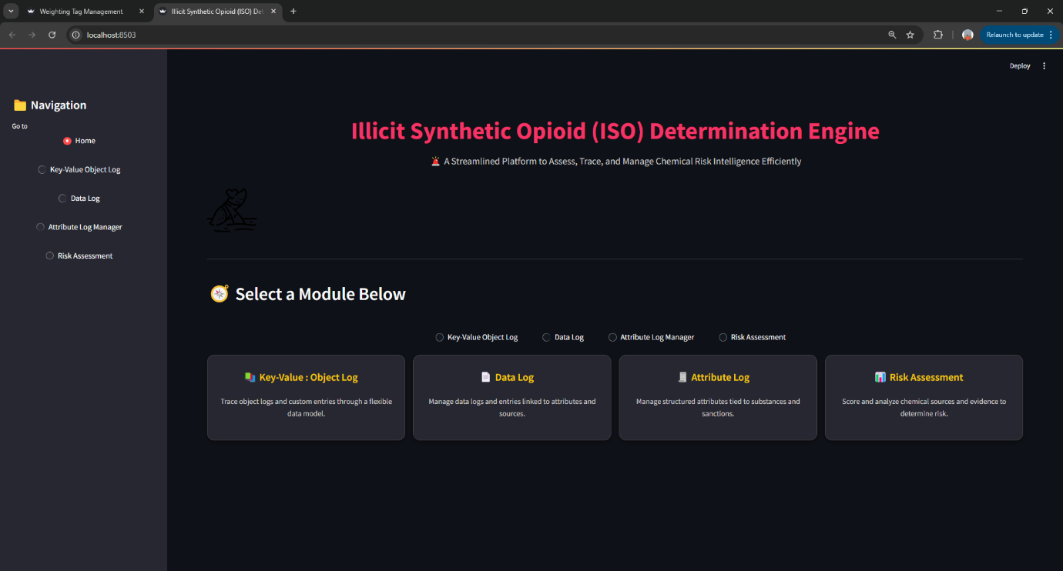

**Figure 36: User Interface for Key Value Sheet & Risk Assessment Model**

The UI introduces three core logging systems: the **Intake Data Log**, **Attribute Log**, and **Object Log**. The **Data Log** captures individual records as they enter the system, including metadata like source, timestamp, and entity name. This is the first stop for any incoming evidence and is structured to be both searchable and editable.

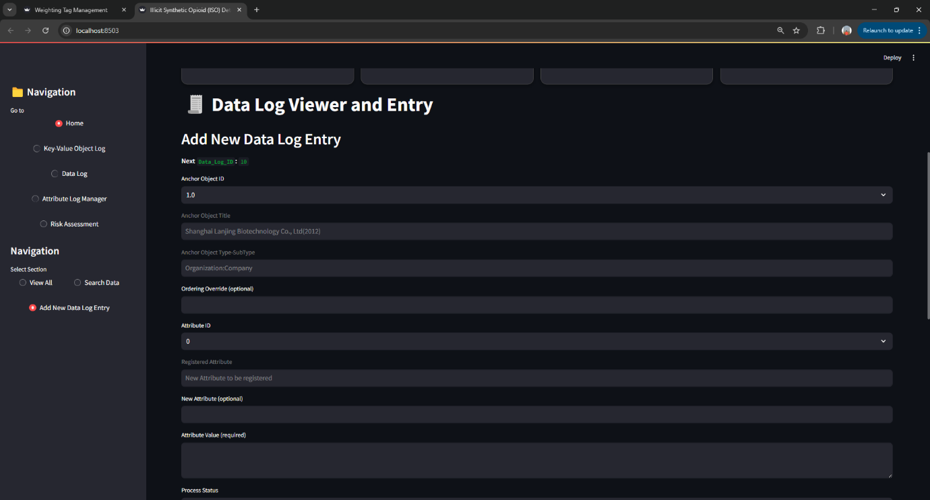

**Figure 37: Data Log with CRUD Details**

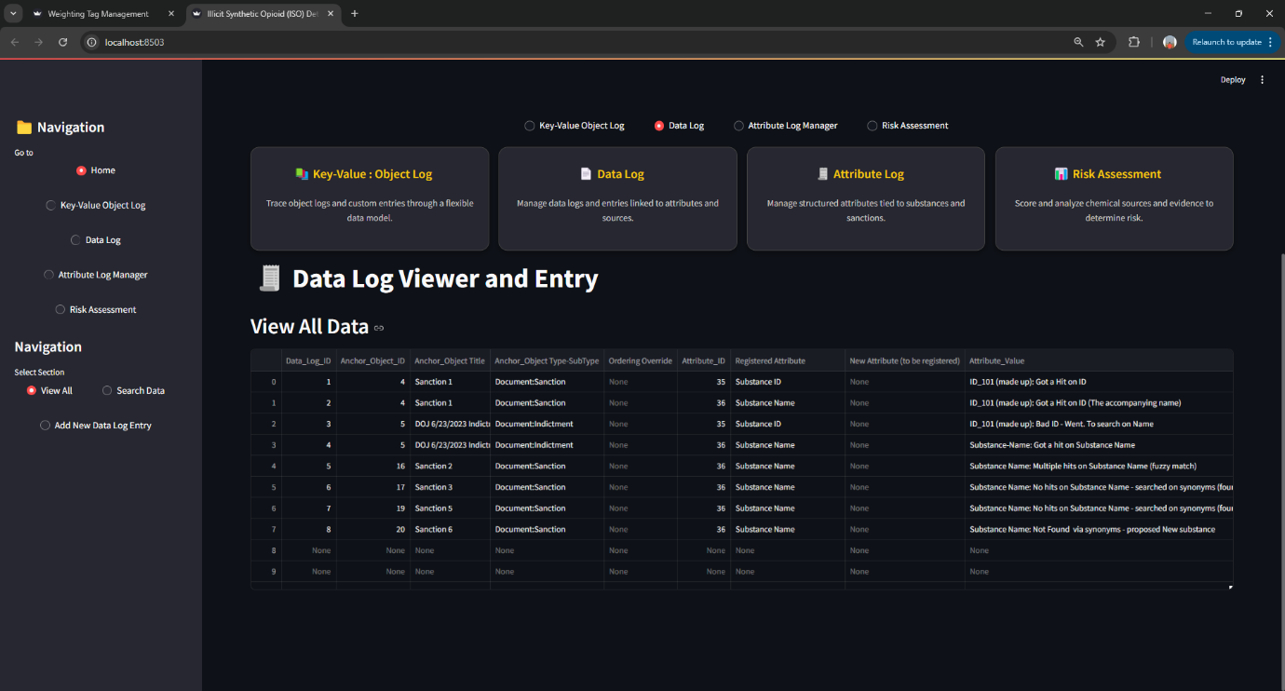

**Figure 38: Data Log with CRUD Details**

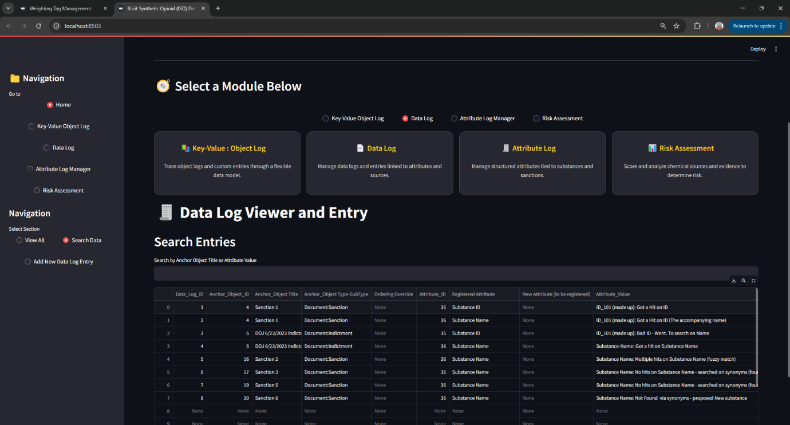

**Figure 39: Data Log with CRUD Details**

The **Attribute Log** stores normalized fields extracted from SecureGPT, such as a case number, charge description, or location. Attributes are the building blocks of evidence structure and enable downstream analytics. Analysts can view, edit, and update fields directly from the interface, supporting iterative refinement.

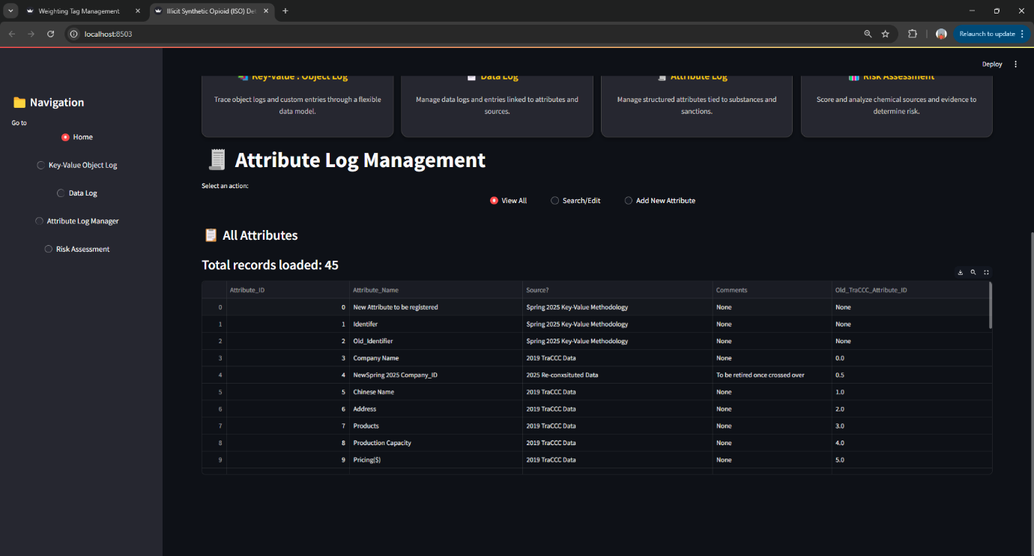

**Figure 40: Attribute Log with CRUD Details**

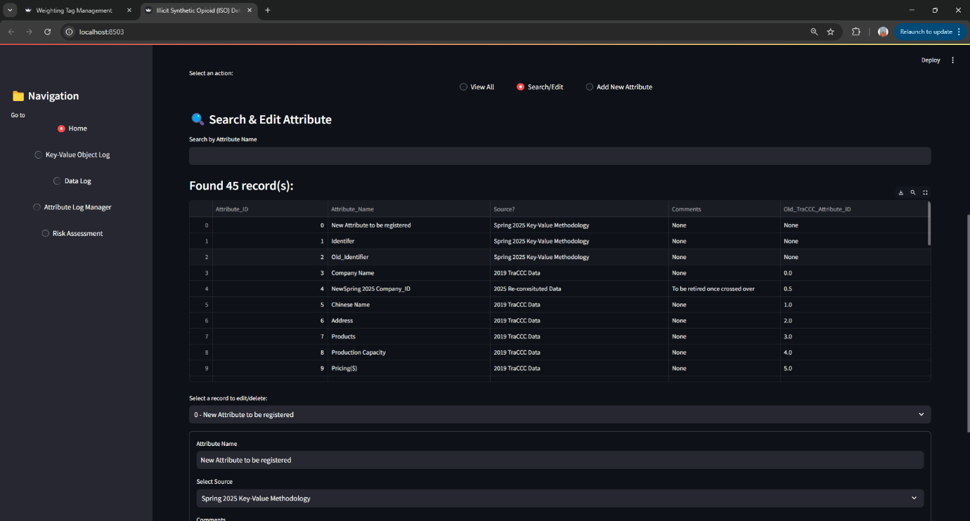

**Figure 41: Attribute Log with CRUD Details**

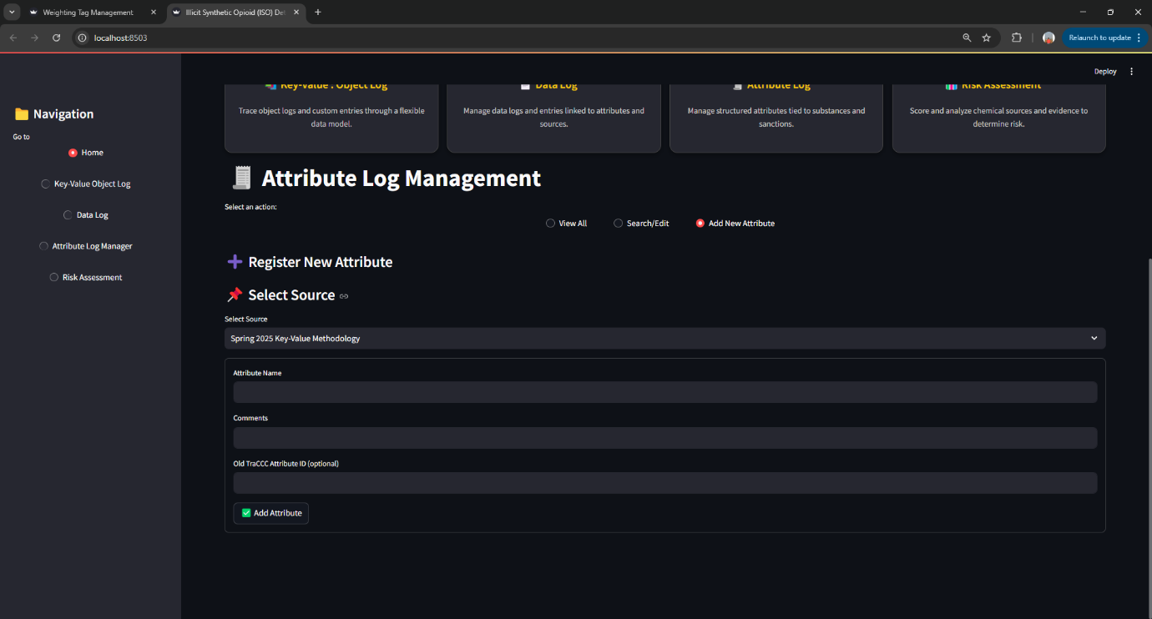

**Figure 42: Attribute Log with CRUD Details**

The **Object Log** maps these attributes to the entities they describe—typically companies or substances. This log is crucial for tracing evidence lineage and for keeping a record of how evidence evolves over time and how it connects to tagged entities.

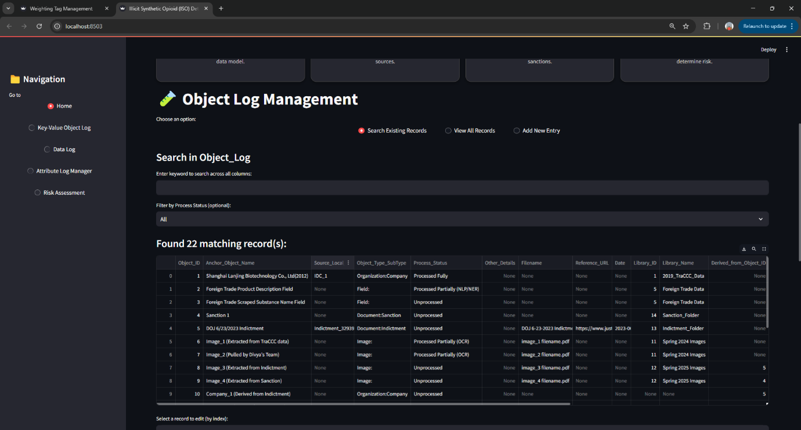

**Figure 43: Object Log with CRUD Details**

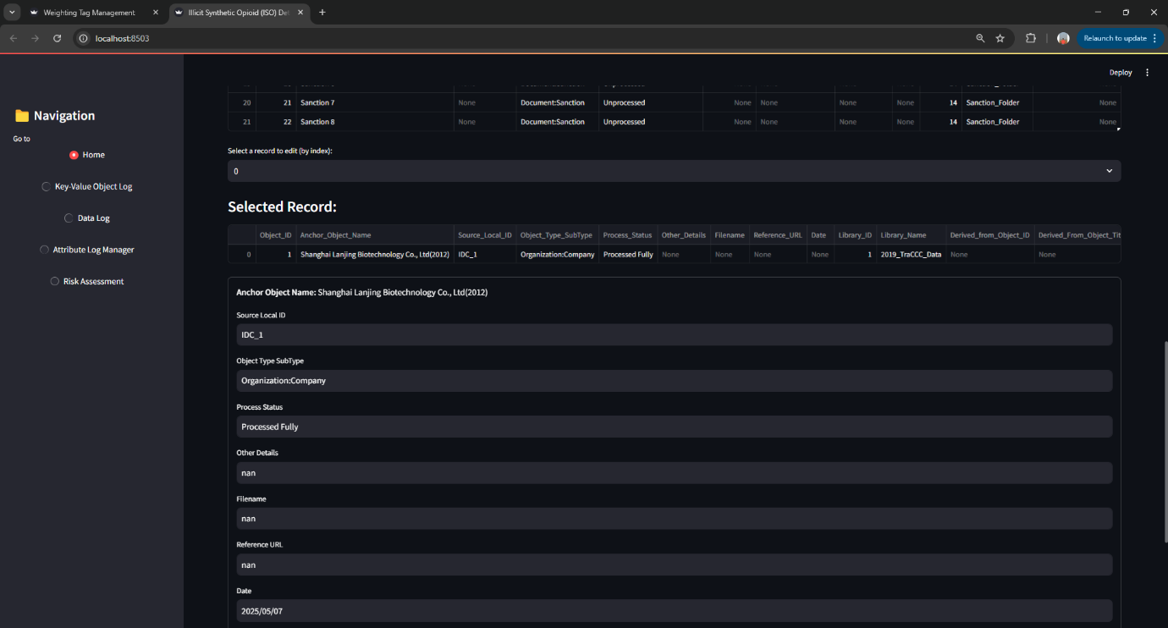

**Figure 44: Object Log with CRUD Details**



**Figure 45: Object Log with CRUD Details**

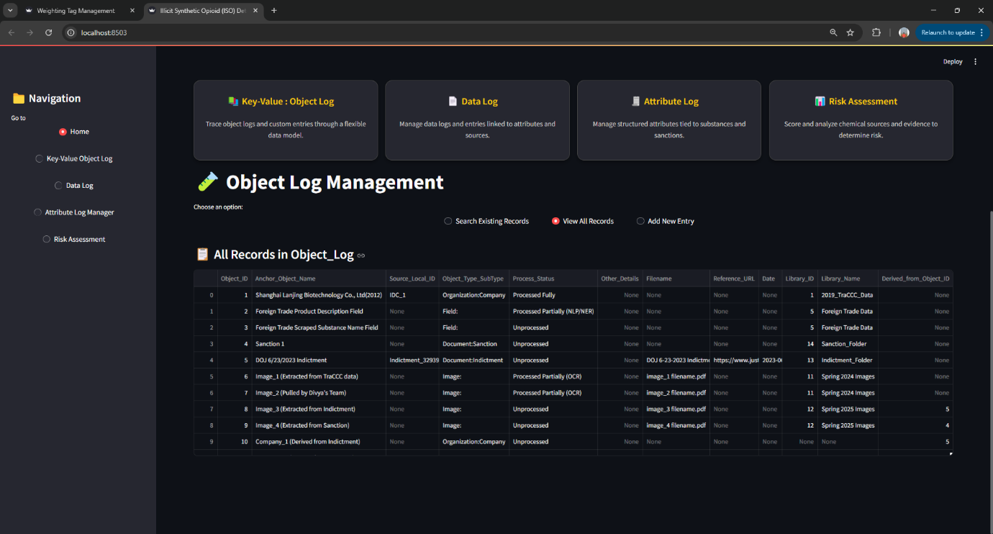

**Figure 46: Object Log with CRUD Details**

Beyond evidence management, this module also includes a **Risk Scoring Prototype** that demonstrates how cumulative risk weights are calculated. In this view, users can select a company or substance, assign weights based on linked evidence, and compute an overall score. The score logic uses a summation of weights and applies severity factors based on tag categories. This feature provides a prototype for what a future enforcement dashboard might include.

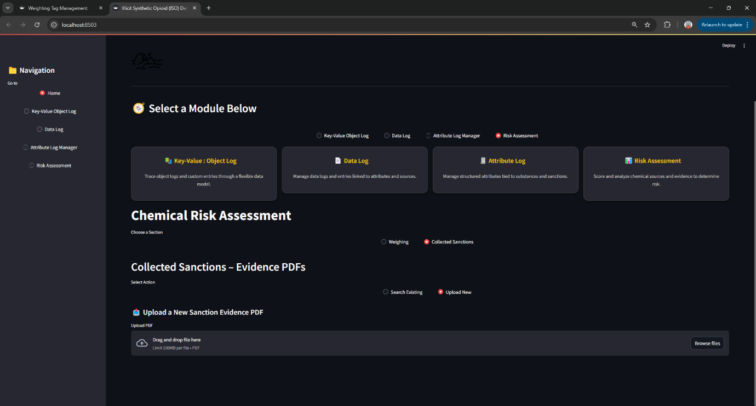

**Figure 47: Risk Assessment Model with CRUD Details**

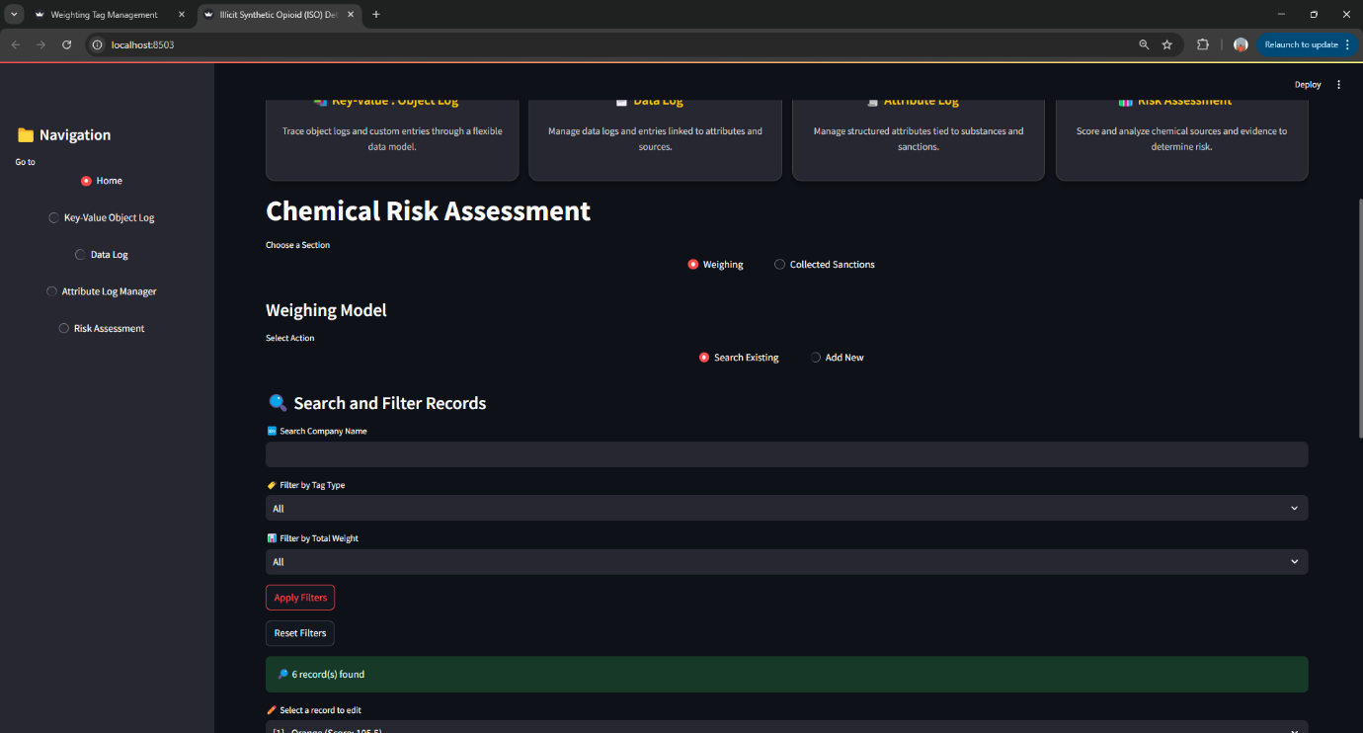

**Figure 48: Risk Assessment Model with CRUD Details**

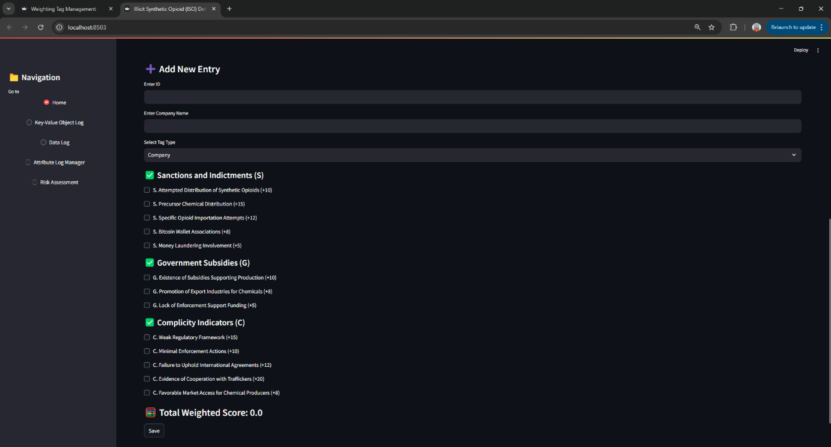

**Figure 49: Risk Assessment Model with CRUD Details**

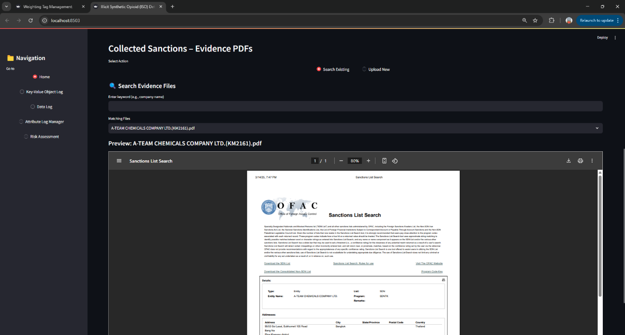

**Figure 50: Risk Assessment Model with CRUD Details**

The risk scoring UI is designed to mimic real-world usage while remaining flexible enough for future feature expansion, such as time-decay adjustments, visual dashboards, or predictive ranking systems.

**4.5 Collaboration Between ISO Determiners and ISO Chemical ID Mappers**

The collaboration between the ISO Determiners and Chemical Mappers was essential to building a unified and scalable data framework. While the Chemical Mappers focused on classifying and sourcing chemical substances, the ISO Determiners were responsible for assigning and managing risk scores based on legal evidence such as sanctions and indictments.

Both teams used a shared tagging infrastructure, built around six central sheets: Weighting_Tag_Type, Weighting_Tag_Category, Weighting_Tag, Company_Weighting_Tag, Substance_Weighting_Tag, and Evidence_Weighting_Tag. This common structure allowed each team to work independently while contributing to the same backend logic.

Chemical Mappers maintained registry-linked details such as CAS numbers and substance types, while ISO Determiners applied scoring tags to those same substances through evidence-based risk indicators. The shared use of the Substance_Reference table created a direct integration point where classification met scoring.

A common user interface framework also allowed both teams to manage their datasets using CRUD operations—ensuring consistency, auditability, and collaboration without conflict.

In summary, this collaboration enabled a seamless bridge between chemical intelligence and enforcement-focused risk scoring, supporting a unified and flexible ISO detection system.

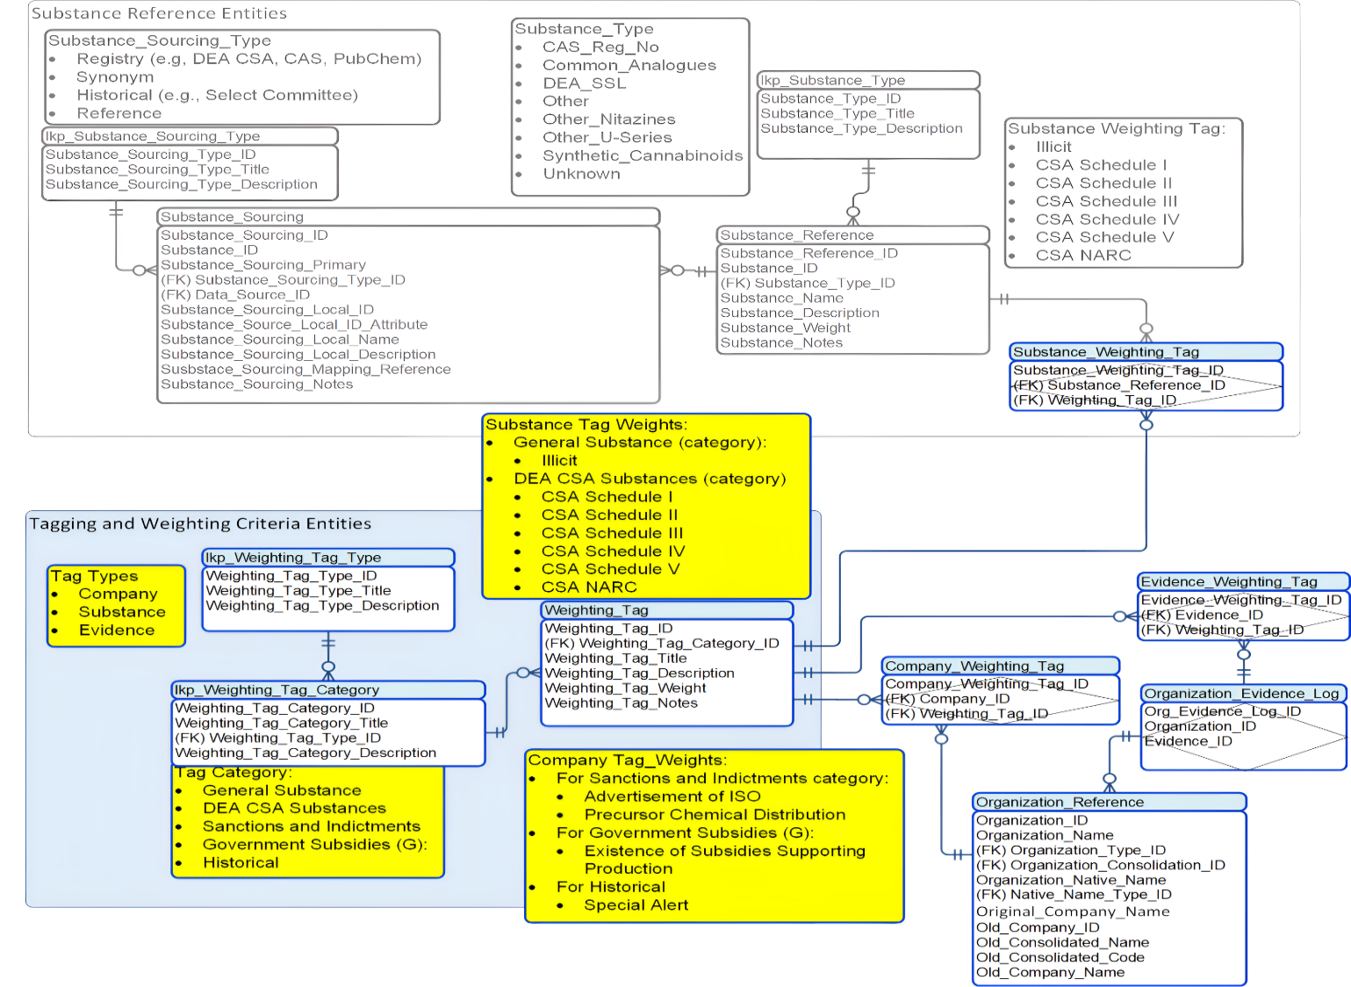

**Figure 51: Collaboration Between Determiners and Chemical ID Mappers**

# Outcomes and Visualizations

## Overview

The Illicit Synthetic Opioid (ISO) Determination Engine is a semi-automated intelligence system designed to support enforcement and policy efforts in combating synthetic opioid trafficking particularly fentanyl and its analogs. The platform focuses on evaluating and ranking the risk profiles of supplier companies by analysing structured evidence of illicit activity, regulatory violations, and state complicity. Rather than solely tracking chemical substances, the system shifts focus to the behaviour of companies involved in the production of synthetic opioids. It empowers users such as DEA agents, policy analysts, and investigative researchers to make informed decisions based on data-backed risk scores and transparent evidence trails.

**Core Capabilities**

**1. End-to-End System Integration**

The ISO Engine integrates all key stages of analysis into a streamlined pipeline:

* Data Ingestion of enforcement records, sanctions, and regulatory documents.
* Secure GPT-Powered Extraction, which automates the parsing of unstructured text (e.g., press releases, case filings) into structured evidence.
* Evidence Tagging and Mapping using a centralized Evidence Tracker.
* Company Linking to associate evidence with known entities and chemical substances.
* Interactive Interface built with Streamlit for intuitive searching, comparison, and review.

This infrastructure allows near real-time evidence processing and risk analysis with minimal manual intervention.

**2. Risk Scoring and Weighting Model**

At the heart of the system is a flexible, rule-based scoring model that calculates a composite risk score for each company:

Risk Score = (Sanctions × 1.2) + (Gov. Actions × 1.1) + (Company Behaviour × 1.3)

Where:

* Sanctions reflect formal legal or regulatory actions,
* Government Actions capture indirect state support or negligence,
* Company Behaviour identifies indicators of trafficking, precursor handling, or regulatory failure.

Each factor is broken down into sub-categories with predefined weights (e.g., “Cooperation with traffickers” = +20), allowing for consistent and explainable scoring.

**3. Evidence-Based Justification and Traceability**

A defining feature of the ISO Engine is its commitment to transparency. Every risk score is traceable to:

* A specific piece of evidence, extracted and tagged using Secure GPT,
* Metadata such as the source type, publication date, and origin,
* A linked tag and score, maintained via a centralized Key-Value Conditioning Sheet.

This ensures scores are not black boxes, but fully explainable outcomes supported by verifiable data.

**4. Usability and Operational Flexibility**

The ISO Determination Engine is designed to support the needs of partners focused on combating illicit synthetic opioid activity through data-driven enforcement, policy, and research.

The platform can be used for:

* Support enforcement-related analysis by identifying and ranking high-risk supplier companies based on verifiable evidence and structured risk scores.
* Enable policy evaluation by allowing analysts to simulate regulatory changes through adjustable risk scoring weights.
* Facilitate research and academic inquiry by providing exportable, structured datasets that can be used for trend analysis, modelling, or integration with broader studies on transnational crime and public health.

The system is scalable and adaptable suitable for hands-on investigative work today, while also offering a foundation for future automation and expanded analytical capability

Therefore, the ISO Determination Engine delivers a powerful, user-friendly framework for **identifying high-risk actors** in the synthetic opioid ecosystem. By combining automated data extraction, structured scoring, and evidence traceability, the system provides actionable intelligence tailored to the needs of enforcement, public health, and investigative communities. This shift from monitoring individual substances to profiling high-risk companies represents a strategic evolution in how we address the opioid crisis.

# Findings

### 1. **Effective Modeling of Company-Level Risk**

Using a weighted scoring system, the team successfully modeled the risk associated with **DEA SLL chemicals** and **linked companies**. By incorporating parameters like:

* **Sanctions and indictments**
* **Government subsidies**
* **Complicity indicators**

The team demonstrated how these indicators can be **quantified and weighted** to yield a **Total Risk Score** using the formula:

Total Score=(S×w1​) +(G×w2​) +(C×w3​)

This approach enabled a **prioritized ranking** of companies in terms of their association with synthetic opioid activity.

### 2. **Entity Detection and Manual Tagging Is Effective**

Our **Named Entity Recognition (NER)** and **manual tagging interface** works. It enables users to:

* Select flagged companies or chemicals
* Label and verify associated risk indicators from source documents
* Store tagged evidence for audit trails

While manual tagging slows things down, it gives us **high precision**, which is critical for sensitive topics like DEA monitoring.

### 3. **Weight Adjustments Impact Final Rankings Significantly**

We tested different combinations of weights (w1, w2, w3) and observed that even slight changes could shift company rankings. For instance:

* Boosting the **Complicity Indicator** weight brought **less legally implicated but suspicious companies** higher in the list.
* Prioritizing **Sanctions** pushed known bad actors to the top (expected behavior).

This shows our model is flexible and we can tune it depending on DEA's priorities (e.g., legal precedent vs. suspicious behavior).

### 4. **Company vs. Chemical Focus Clarity**

**We’re prioritizing companies over chemicals**, even though chemicals feed into the risk model. As outlined in the report:

"The chemical is only a factor in calculating the score, but the entity of interest remains the company."

### 5. **UI and Backend Integration**

We’ve developed a fully functional end-to-end system that transforms raw evidence into actionable intelligence. The core workflow includes:

* Uploading documents
* Identifying entities (e.g., companies, chemicals)
* Tagging evidence based on standardized rules
* Applying a weighted risk scoring model
* Generating a sorted output of high-risk companies

While the backend handles data processing and scoring, the user interface (UI) is built to support practical, real-world interaction. The current UI allows users to:

* Perform CRUD operations on evidence and scoring parameters
* Search and retrieve company records based on risk profiles or identifiers
* Manually tag evidence associated with specific entities
* Compare companies across risk dimensions
* Adjust weighting parameters to simulate different enforcement or policy strategies

Although document processing and entity extraction are handled in the backend, the UI remains streamlined and responsive, optimized for usability by analysts and enforcement professionals.

### **Evidence-Based Justification Adds Transparency**

One of our most valuable findings is that **every risk score is backed by tagged evidence**. This makes our system not just predictive, but **explainable and defensible** something stakeholders would highly value.

We can export:

* Scores
* Raw tagged documents
* Reasoning per company

# Summary

The Illicit Synthetic Opioid (ISO) Determination Engine is a semi-automated analytical platform developed to support the detection, monitoring, and risk assessment of companies involved in the trafficking of synthetic opioids especially fentanyl and its chemical precursors. The system was created in collaboration with partners such as TRACCC at George Mason University and MITRE, who identified the critical need for scalable tools to track and prioritize high-risk entities in global supply chains.

At its core, the system ingests publicly available regulatory and enforcement data, including DOJ press releases, OFAC sanctions lists, DEA Special Surveillance List (SSL) entries, and trade reports. Using a combination of Secure GPT-powered extraction and rule-based processing, it identifies references to relevant companies, chemicals, and countries. The extracted evidence is then tagged manually or semi-automatically to highlight indicators of illicit activity, such as involvement in trafficking networks, regulatory evasion, or state-linked protection.

A custom-built weighted risk scoring model calculates a Total Risk Score for each company based on three core factors:

* Sanctions and Indictments (S)
* Government Subsidies and Complicity (G)
* Behavioral Indicators (C)

The scoring formula is configurable, allowing users to adjust the weights and explore how different priorities affect the ranking of companies. These scores are presented through a user-friendly Streamlit dashboard, which supports CRUD operations, search functionality, company comparisons, and weight adjustments.

One of the system’s most valuable features is its commitment to transparency and explainability. Each risk score is fully traceable to specific pieces of tagged evidence, complete with source metadata such as publication date, issuing agency, and document type. This makes the tool not only operationally useful but also defensible for legal, policy, and audit purposes.

While the system is not fully automated, its semi-automated architecture strikes a practical balance between machine-driven efficiency and human judgment particularly when interpreting complex legal language or context-specific risk factors. This approach reduces false positives while maintaining analytical rigor.

The ISO Determination Engine provides a strong proof-of-concept for how data science and open-source intelligence can enhance the visibility of illicit supply chains. It lays a solid foundation for future enhancements, such as real-time monitoring, automated tagging pipelines, and integration with larger threat intelligence systems.

# Future Work

While the ISO Determination Engine establishes a solid foundation for semi-automated risk assessment in synthetic opioid trafficking, several technical, operational, and strategic enhancements are necessary to maximize its real-world impact. Below are the key areas for future development:

**1. Automated Evidence Collection**

* Implement full automation of data collection from structured and unstructured government sources.
* Develop real-time scraping and ingestion pipelines using secured scrapping tools.
* Expand coverage to include news articles, court filings, academic reports, and trade documents using advanced NLP methods.

**2. Risk Model Expansion**

* Apply data-driven weight optimization techniques (e.g., regression, AHP).
* Incorporate confidence intervals or uncertainty scoring to better reflect evidence strength and data quality.

**3. Multilingual & Cross-Border Entity Resolution**

* Build advanced entity resolution models to link aliases and name variations across jurisdictions.
* Extend Named Entity Recognition (NER) to process documents in key non-English languages (e.g., Chinese, Spanish, Russian).
* Develop tools for global supply chain tracking of precursor chemicals.

**4. Operational Readiness & User Roles**

* Implement secure, role-based access control for multi-user environments (analysts, reviewers, admins).
* Enable audit trails for all system actions to support traceability and accountability.
* Support collaborative workflows for tagging, verification, and peer review.

**5. User Interface Enhancements**

* Develop dynamic dashboards for temporal risk tracking and trend analysis.
* Enable real-time weight simulations and exportable stakeholder reports for decision-making support.

**6. Security, Ethics, and Legal Compliance**

* Ensure compliance with privacy laws (e.g., GDPR, CCPA) in handling sensitive data.
* Apply robust security protocols to protect user data, evidence records, and backend systems.
* Implement fairness checks and bias audits to uphold ethical standards and prevent unjust risk labeling.

**7. Long-Term Vision: Full Intelligence Engine**

* Introduce real-time alert systems for high-risk activity detection.
* Enable investigator-specific dashboards and custom risk profiles.
* Explore blockchain integration for tamper-proof tracking of precursor chemical movements.
* Partner with border agencies and customs officials to feed insights into enforcement workflows.

The proposed roadmap reflects both the challenges and opportunities in scaling the ISO Determination Engine into a robust intelligence platform. Future work should prioritize automation, machine learning integration, multilingual support, and real-world operational readiness to ensure the system continues to deliver high-impact, actionable intelligence to enforcement, policy, and research communities.

**This page intentionally left blank**

Appendix

Appendix A: Domain Background

I. Introduction

Fentanyl, a synthetic opioid, has become a major public health crisis due to its extreme potency, low production cost, and widespread illegal distribution. Originally developed as a pain reliever for cancer patients, fentanyl is now a leading cause of overdose-related deaths worldwide. Unlike naturally derived opioids like morphine and heroin, fentanyl is entirely synthetic and 50 to 100 times stronger than morphine [8].

The crisis is fueled by illicitly manufactured fentanyl, which is frequently mixed with heroin, cocaine, or counterfeit prescription pills. These mixtures make it difficult for users to determine the strength of the drugs they consume, significantly increasing the risk of fatal overdoses [9]. The primary supply chain for illicit fentanyl begins with precursor chemicals from China, which are then processed in Mexico before being smuggled into the United States through well-established drug trafficking networks [10]. Despite significant efforts by U.S. law enforcement agencies, including Customs and Border Protection (CBP) and the Drug Enforcement Administration (DEA), drug traffickers continue to adapt, taking advantage of regulatory loopholes and online marketplaces to expand their operations [8].

**II. The Fentanyl Crisis and Its Origins**

**A. Medical and Illicit Use of Fentanyl**

Fentanyl was first synthesized in 1960 by Dr. Paul Janssen as a powerful painkiller for patients undergoing surgery, cancer treatments, and palliative care. While fentanyl remains valuable in medical settings, its potency also makes it highly addictive and dangerous when misused.

Illicitly manufactured fentanyl is produced without the strict safety and quality controls applied to pharmaceutical fentanyl, leading to extreme variations in potency. Users may unknowingly consume doses that are far stronger than their tolerance, leading to a sharp rise in overdose deaths. According to the Centers for Disease Control and Prevention (CDC), synthetic opioids like fentanyl are involved in more than 70% of opioid-related overdose deaths in the United States [9].

**B. The Role of China and Mexico in the Supply Chain**

China has historically been the largest supplier of fentanyl precursor chemicals. Despite efforts by Chinese authorities to regulate these substances, many unregulated chemical analogs are still produced and exported under different names [10]. These chemicals are then trafficked to Mexico, where drug cartels manufacture fentanyl before smuggling it into the United States.

Mexican drug cartels, such as the Sinaloa Cartel and Jalisco New Generation Cartel (CJNG), play a central role in fentanyl production and distribution. These organizations use sophisticated smuggling operations to evade law enforcement and supply the U.S. drug market. Once inside the United States, fentanyl is often mixed with other illicit drugs, further increasing the risk of accidental overdoses.

The following table summarizes the roles of each region in the fentanyl supply chain:

| **Region** | **Role in Supply Chain** |
| --- | --- |
| **China** | Main producer of precursor chemicals; some chemicals are legally exported but diverted to illicit use. |
| **Mexico** | Manufacturing hub for synthetic opioids like fentanyl using Chinese precursors. |
| **U.S.** | Primary consumer market: enforcement efforts focus on intercepting drug shipments and dismantling trafficking networks. |

**C. Distribution and Trafficking Methods**

To evade law enforcement, traffickers use various smuggling methods, including:

1. Dark Web and Cryptocurrencies – Online marketplaces allow anonymous drug sales, making it harder to trace transactions.
2. International Postal Services – Small packages containing fentanyl or precursor chemicals are shipped through standard mail services to avoid detection.
3. Border Smuggling through Mexico – Fentanyl is transported in hidden compartments inside vehicles or mixed with legitimate cargo shipments.
4. Counterfeit Prescription Pills – Traffickers press fentanyl into fake pills resembling prescription opioids such as Oxycodone or Xanax, misleading users [8].

**III. Public Health Impact of the Fentanyl Crisis**

**A. Overdose Trends and Mortality Rates**

The fentanyl crisis has led to a significant increase in overdose deaths in the United States. The CDC reports that over 70,000 overdose deaths in 2022 were linked to synthetic opioids, primarily fentanyl [9].

Fentanyl’s extreme potency means that even 2 milligrams—equivalent to a few grains of salt—can be a fatal dose for many individuals. Overdose symptoms include:

* Severe respiratory depression (slowed or stopped breathing)
* Loss of consciousness
* Confusion and drowsiness
* Blue-tinted skin (cyanosis) due to lack of oxygen

To counteract fentanyl overdoses, Naloxone (Narcan) is widely used as an emergency treatment. However, because fentanyl is much stronger than heroin, multiple doses of naloxone may be needed to reverse an overdose.

**IV. Economic and Social Impact**

The fentanyl crisis extends beyond public health it has severe economic and social consequences:

* Strain on Healthcare Systems - Hospitals and emergency responders struggle to handle the increasing number of overdose cases.
* Law Enforcement Costs - Drug enforcement requires massive resources, increasing the burden on law enforcement agencies.
* Workforce and Productivity Losses - Many fentanyl overdose victims are between ages 18 - 45, leading to a decline in economic productivity.
* Community Devastation - Families and local communities suffer from addiction-related crime, unemployment, and social instability [10].

**V. Law Enforcement and Regulatory Responses**

**A. U.S. Customs and Border Protection (CBP)**

* CBP has strengthened border security using advanced drug detection technologies such as X-ray scanners, K-9 units, and chemical analysis tools.
* In 2023, CBP seized over 27,000 pounds of fentanyl, preventing millions of lethal doses from reaching U.S. communities [8].

**B. Drug Enforcement Administration (DEA)**

* The DEA’s "One Pill Can Kill" initiative raises awareness about counterfeit pills containing fentanyl.
* DEA task forces work with Mexican law enforcement to shut down illicit fentanyl production labs.
* The DEA Special Surveillance List (DEA SLL) helps track high-risk precursor chemicals.

**C. Government Accountability Office (GAO) Recommendations**

* A GAO report emphasized the need for stronger interagency cooperation and enhanced tracking of synthetic opioids across postal and commercial shipping networks [10].
* The GAO has recommended expanding forensic analysis capabilities to improve tracking of fentanyl production methods.

**D. Legislative and Policy Measures**

* The FEND Off Fentanyl Act (S. 1271) proposes stricter penalties for fentanyl trafficking and aims to block financial transactions linked to drug cartels.
* The U.S. government continues to engage in diplomatic efforts with China and Mexico to reduce the flow of precursor chemicals [11].

**VI. Work done by Previous Semester Teams**

Before we, the students of Spring 2025, started working on this project, students from two previous semesters Spring 2024 and Fall 2024 had already contributed to it. The following explanation provides a brief introduction to their work.

In the Spring of 2024, the research teams deepened their investigation into government involvement and corporate deception within the fentanyl trade. Their analysis identified 22 companies engaged in government-supported production, with 14 key connections emerging from TraCCC data and two major corporations linked to both PRC Known Associations and active fentanyl manufacturers. By mapping over 140 corporate aliases, the teams exposed deliberate efforts to obscure identities and evade detection. Further network analysis revealed more than 76 identity linkages, shedding light on the complex network of fentanyl producers. The project’s impact extended beyond individual company investigations, as heatmaps and visualizations highlighted major fentanyl hubs in cities like Shanghai, Wuhan, and Jiangsu. Through structured datasets and scalable data models, the research team equipped law enforcement and policymakers with essential tools to monitor, track, and dismantle illicit fentanyl supply chains, contributing a significant step forward in combating the global opioid crisis.

Expanding on this work Fall 2024, multiple teams collaborated to address the rising issue of illicit fentanyl trade using advanced data analytics and investigative techniques. Their research involved extracting key evidence from images and unstructured text, uncovering 131 organizations, 34 suspicious keywords, and 31 foreign trade company links. By utilizing Optical Character Recognition (OCR) and Natural Language Processing (NLP), they automated the identification of fentanyl-related entities, ensuring scalability for future investigations. Additionally, network analysis revealed shared phone numbers among various companies, exposing coordinated operations within the fentanylsupply chain. Through the standardization and integration of company and contact data, the teams enhanced traceability and developed an interactive, structured database for deeper analysis. Their work resulted in actionable intelligence aimed at aiding law enforcement in dismantling illegal networks and strengthening interdiction efforts.

**VII. Methodologies for Applying ISO Determiners in Illicit Drug Trade Analysis**

To effectively utilize ISO determiners in analyzing illicit drug trade, the following methodologies are employed:

* Data Scraping & Cross-referencing: Extracting data from regulatory databases such as DEA Special Surveillance Lists and TraCCC research reports [12].
* Heuristic Modeling: Developing algorithms that assess substances based on structural similarities to known illicit drugs and their precursors.
* Supply Chain Analysis: Mapping the flow of precursor chemicals from manufacturers to distributors to identify suspicious activity.
* Surveillance Integration: Using intelligence reports, forensic data, and law enforcement case studies to validate ISO determiner classifications.

**VIII. Challenges in Implementing ISO Determiners**

Despite their potential, several challenges exist in applying ISO determiners effectively:

* Evolving Chemical Structures: Illicit drug manufacturers continuously modify fentanyl analogs to evade regulations, making detection and classification difficult [14].
* Limited International Cooperation: Regulatory misalignment between China, Mexico, and the U.S. hinders enforcement efforts. Need for better data-sharing agreements between agencies.
* Dark Web and Cryptocurrency Transactions: Many fentanyl transactions occur via dark web marketplaces, using cryptocurrency payments, making it harder for authorities to track illicit financial flows.

**IX. Conclusion and Future Research**

The fentanyl crisis is a rapidly evolving challenge, requiring continuous efforts from law enforcement, policymakers, and researchers. Future research priorities include:

1. Using AI-driven models to classify new fentanyl analogs and precursors.
2. Enhancing cross-border cooperation between China, Mexico, and the U.S. to regulate precursor chemicals.
3. Improving financial tracking of illicit drug proceeds through cryptocurrency and online transactions.

By implementing ISO determiners, machine learning, and improved regulatory measures, law enforcement agencies can more effectively track, intercept, and prevent fentanyl trafficking, ultimately saving lives.

**Appendix B: Glossary**

|  |  |
| --- | --- |
| **Term** | **Definition** |
| **AI (Artificial Intelligence)** | Systems that mimic human intelligence; used here for classifying fentanyl analogs and identifying risk patterns. |
| **Anomaly Detection** | Machine learning technique to identify unusual patterns or outliers, e.g., suspicious entities in datasets. |
| **CBP (Customs and Border Protection)** | U.S. agency responsible for securing borders and preventing illicit trafficking, including fentanyl. |
| **CDC (Centers for Disease Control and Prevention)** | U.S. health agency that tracks opioid-related mortality and overdose trends. |
| **Complicity Indicators** | Behavioral or contextual clues indicating company involvement in illicit activity (e.g., trafficking cooperation). |
| **Cryptocurrency** | Digital currency used for anonymous online transactions, often linked to dark web fentanyl sales. |
| **DEA (Drug Enforcement Administration)** | U.S. federal agency combating drug trafficking and controlling substances like fentanyl. |
| **DEA SLL (Special Surveillance List)** | DEA list of precursor chemicals frequently used in the illicit production of controlled substances. |
| **Dark Web** | A hidden part of the internet used for untraceable, illegal transactions including fentanyl sales. |
| **Entity Resolution** | Linking different representations of the same company or entity across datasets (e.g., aliases). |
| **FEND Off Fentanyl Act** | U.S. legislation aimed at increasing penalties for fentanyl trafficking and disrupting cartel finances. |
| **Fentanyl** | A synthetic opioid, 50–100 times stronger than morphine, responsible for a large number of overdose deaths. |
| **GNN (Graph Neural Network)** | A machine learning model that uncovers complex relationships between entities (e.g., companies, chemicals). |
| **Heuristic Modeling** | Rule-based method to evaluate substances and entities based on observed behaviors or features. |
| **ISO Determiners** | A system developed to classify and assess risk of entities involved in synthetic opioid trafficking. |
| **ISOs (Illicit Synthetic Opioids)** | Synthetic opioids like fentanyl, illegally produced and distributed. |
| **NER (Named Entity Recognition)** | NLP technique used to extract names of people, organizations, chemicals from text. |
| **NLP (Natural Language Processing)** | AI field used to analyze and extract insights from human language in documents. |
| **Naloxone (Narcan)** | Emergency medication used to reverse opioid overdoses, including fentanyl. |
| **OFAC (Office of Foreign Assets Control)** | U.S. agency managing sanctions; a key source for identifying high-risk entities. |
| **OCR (Optical Character Recognition)** | Converts images or scanned documents into machine-readable text. |
| **One Pill Can Kill** | DEA initiative to raise awareness of counterfeit pills containing fentanyl. |
| **Precursor Chemicals** | Raw materials used to manufacture synthetic opioids like fentanyl. |
| **Random Forest / XGBoost** | Machine learning algorithms used for classification and prediction in risk modeling. |
| **Risk Scoring** | Assigning numerical risk levels to entities based on defined indicators. |
| **Sanctions** | Government-imposed penalties on individuals or companies involved in illicit activities. |
| **Secure GPT** | GPT-powered tool used to securely extract and process evidence from legal/regulatory text. |
| **Sinaloa / CJNG Cartels** | Major Mexican drug trafficking organizations central to fentanyl production and smuggling. |
| **Structured vs. Unstructured Data** | Organized (tables, databases) vs. raw, unformatted data (text, documents, images). |
| **Synthetic Opioids** | Man-made opioids designed to mimic effects of natural opioids; often stronger and riskier. |
| **TraCCC (Terrorism, Transnational Crime and Corruption Center)** | A research institute at George Mason University contributing to data and analysis on synthetic opioid trafficking. |

Appendix C: GitHub Repository

Overview

GitHub Repository Link

https://github.com/Vkrishna06/ISO-determiners

GitHub Repository Contents

The ISO Determiners project repository serves as the central location for all components of our capstone solution: a semi-automated system for detecting and prioritizing entities involved in the illicit synthetic opioid supply chain. Developed under the DAEN-690 course at George Mason University, this project combines data engineering, evidence tagging, dynamic risk modeling, and dashboard visualization into a modular and scalable platform. The system is designed with real-world enforcement use in mind, focusing on risk scoring companies (rather than just chemicals) based on traceable evidence from reputable government sources.

Unlike traditional tools that rely on static spreadsheets, ISO Determiners introduces a flexible data model where both companies and substances are scored using a weighted system that reflects the severity of evidence types. All elements of the system- from tagging, scoring, to final output-are documented and implemented in code, stored in this GitHub repository. The structure and readability of the repo aim to match the standards of a professional engineering project and include detailed instructions for use, contribution, and customization.

Key Features of the Repository

Evidence Tagging System

Uses a structured three-level tagging model (weighting_tag_type, weighting_tag_category, and weighting_tag) to classify all forms of evidence including sanction lists, and government reports.

Substance Weighting Tags

Chemicals are tagged and linked to substance_reference_entities, allowing substances to influence risk scores alongside company actions.

Evidence Logging and Traceability

Each tag and score can be traced back to its source using an Object Log, Attribute Log, and Evidence Data Log, making the system transparent and defensible.

Interactive Streamlit Dashboard

Allows users to adjust risk weights, Upload or review documents,Search for companies,View rolled-up scores,Export results.This makes the system accessible even to non-technical users like investigators or analysts.

Appendix D: Risks

Sprint 1 Risks

During this sprint1, the team undertook a structured risk assessment at the outset, refining it continuously based on technical progress and user feedback. Risks were identified through collaborative brainstorming involving data scientists, domain experts, and system engineers. This cross-functional approach proved essential in surfacing risks from technical, analytical, and operational angles. Mitigation strategies were drawn from industry best practices and prior experience with similar modeling initiatives.

The team’s early identification of critical risks such as data reliability and algorithmic accuracy—ensured that safeguards like data validation and fairness audits were embedded into development workflows from the beginning. Additionally, continuous testing of the weighted model allowed the team to detect and resolve issues in edge cases before deployment. However, not everything went perfectly. The initial structure of the weighting model lacked defined caps and minimums, leading to inconsistent outputs during early testing. With a more thoroughly defined framework up front, some rework could have been avoided. Moreover, user-facing concerns such as model interpretability and transparency weren’t fully addressed until later in the sprint, when they emerged more clearly during stakeholder feedback sessions.

On the whole, the team accurately identified most major technical and data-related risks, but underestimated some operational challenges particularly the reliance on timely updates from external data sources, which led to unforeseen delays. One unanticipated issue was the latency involved in cross-checking external chemical databases, which impacted data ingestion speed. Another was the inconsistent chemical nomenclature across data sources, which introduced complexity in integration not initially accounted for. Despite these surprises, the risk assessment process laid a solid foundation for managing complexity, and future teams are encouraged to apply a similarly proactive and multidisciplinary approach.

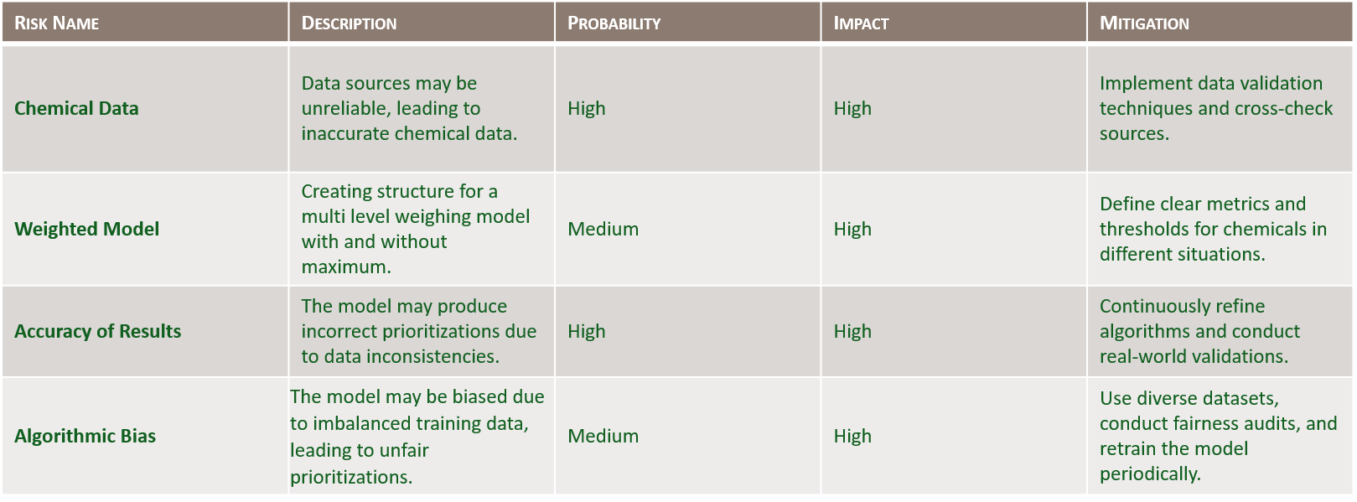

Table 2: Sprint 1 Risks

Sprint 2 Risks

During the sprint2, the team carefully identified and documented potential risks associated with managing and processing external data sources. This process began with collaborative planning sessions involving data engineers, project managers, and security specialists to capture both technical and operational risks. These sessions were instrumental in surfacing concerns early and defining mitigation strategies rooted in practical experience and existing workflows.

One of the major strengths of this sprint was the team’s awareness of data inconsistency issues. Recognizing that integrating data from various sources could introduce format and structural discrepancies, the team wisely implemented standardization and cleaning procedures upfront, which significantly improved downstream reliability. The proactive approach to **version control** was also a success. By deploying a lightweight version control system and clearly documenting changes, confusion was minimized despite multiple contributors updating files simultaneously.

The team also correctly anticipated risks around missing or incomplete data, putting checks in place to validate and supplement gaps using secondary sources. Security and storage were prioritized, with strong access controls and cloud-based encryption mechanisms adopted early on, minimizing exposure to potential breaches.

However, there were areas where the team could have improved. The manual nature of early data validation created significant delays before automation scripts were developed. Had automation been prioritized sooner, the team could have saved valuable time and resources. Additionally, while most risks were well-identified, there was some underestimation of the effort needed for maintaining automation scripts and scheduling periodic updates, particularly as new data formats emerged.

An unanticipated risk emerged when different teams used inconsistent naming conventions for evidence types, which wasn’t caught until later in the sprint. This caused minor disruptions in the integration pipeline and required rework to harmonize terminology across modules.

In hindsight, this sprint validated the importance of proactive planning, especially around data handling and security. Future project teams are encouraged to prioritize automation earlier in the sprint, maintain consistent naming conventions across teams, and invest time in creating robust documentation and validation layers from day one. These actions can dramatically reduce rework and improve project velocity and data integrity across similar efforts.

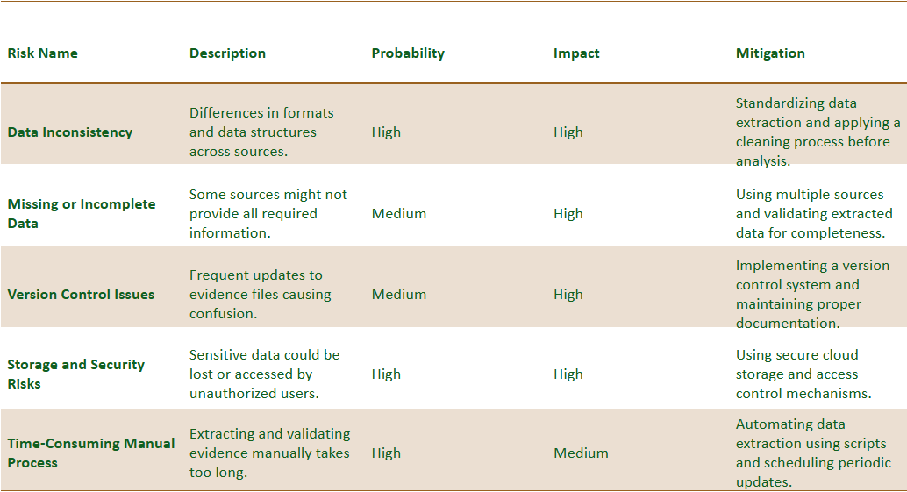

Table 3: Sprint 2 Risks

Sprint 3 Risks

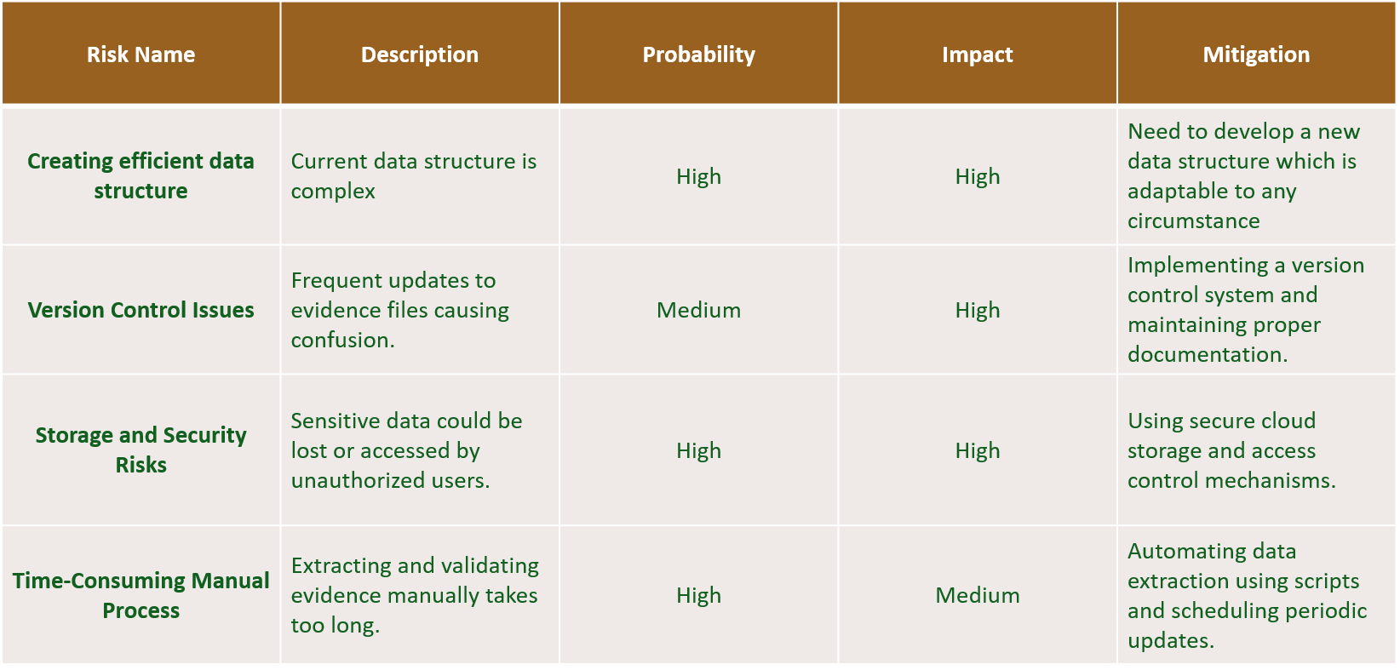

Table 4: Sprint 3 Risks

In this sprint, the team identified several critical risks tied to the structure, security, and handling of data. The risk assessment was conducted during the planning phase through working sessions with system architects, backend developers, and analysts, ensuring a comprehensive understanding of potential pitfalls. The risks were not only identified early but also continually re-evaluated throughout development as new technical requirements surfaced.

A standout success in this sprint was the early recognition that the existing data structure was too complex for scalability. The team addressed this by beginning work on a more modular and adaptive structure that could evolve with the project. This forward-thinking decision helped reduce long-term rework and enabled smoother integration with other components.

Another key area the team got right was version control. While frequent file updates initially created confusion, implementing a proper version control system mid-sprint significantly improved traceability and collaboration. Similarly, security concerns were proactively managed by leveraging cloud-based storage solutions with access controls preventing any security breaches or loss of data.

Despite these successes, there were areas for improvement. The manual extraction and validation of evidence took longer than expected early in the sprint. Automation was discussed but not prioritized soon enough. Once implemented, automation scripts drastically improved efficiency—highlighting the importance of addressing manual workflows at the start of the sprint. Additionally, while risks were accurately forecasted overall, the complexity of adapting a new data structure in a live development environment was slightly underestimated, causing short delays in implementation and testing.

No major unanticipated risks emerged, but some integration friction was encountered as the new structure had to be reconciled with legacy components still in use. This emphasized the need for better communication between architecture and development sub-teams regarding system-wide changes.

Sprint 4 Risks

|  |  |  |  |  |
| --- | --- | --- | --- | --- |
| Risk Area | Issue | Probability | Impact | Mitigation |
| Secure GPT Adaptation | Secure GPT setup may not align with project requirements or constraints | Medium | High | Conduct compatibility checks; define clear input/output formats |
| Data Organization Issues | GPT responses are unstructured and difficult to map to our schema | High | High | Design a standardized schema to parse and classify GPT outputs |
| UI Integration Challenges | Integrating Excel sheets into Streamlit causes errors | Medium | Medium | Use correct data types and convert formats |

Table 5: Sprint 4 Risks

During this sprint, the team identified and documented several critical risks related to integrating Secure GPT and managing UI functionality using Streamlit. The key risks included challenges in adapting Secure GPT to align with our project requirements, handling unstructured GPT outputs that did not map cleanly to our backend schema, and integrating Excel-based datasets into the UI without causing rendering or formatting errors. These risks were evaluated in terms of their likelihood and impact, with appropriate mitigation strategies such as schema standardization, input/output formatting, and robust data type handling.

The team was largely successful in anticipating these risks early in the sprint. For example, we correctly foresaw the issue of unstructured GPT responses and proactively worked on a parsing schema to manage them. Similarly, we identified that Excel-to-Streamlit integration. However, some areas could have been improved. Specifically, we underestimated the variability of GPT output formats and the time required to refine a parsing logic, which led to some avoidable rework. In addition, although we predicted potential UI inconsistencies, we did not fully plan for how Streamlit would react to malformed or missing backend data, which resulted in some component failures.

While we effectively predicted most of the technical challenges, the impact of unstructured GPT data proved more disruptive than expected. Additionally, one unanticipated issue arose when Streamlit inconsistently rendered Excel structures under different data loads this had not been flagged during initial planning.

As a takeaway, we recommend future teams treat GPT integration as a core system component rather than a secondary tool. Establishing a rigorous schema for parsing, validating, and storing AI-generated content is essential. We also suggest stress-testing UI components with edge cases, including empty or malformed data, and maintaining centralized logging for all exceptions. These lessons helped us improve system resilience and would greatly benefit any project team pursuing a similar implementation.

Sprint 5 Risks

| **Risk** | **Description** | **Probability** | **Impact** | **Mitigation** |
| --- | --- | --- | --- | --- |
| Presentation Readiness Delay | Team struggled to finalize slides and content due to ongoing development tasks. | Medium | High | Allocate a fixed time block exclusively for slide prep before sprint ends. |
| Coordination Gaps | Difficulty aligning with teammates for dry runs and dividing presentation flow. | Medium | Medium | Schedule a shared rehearsal calendar and assign slide sections early. |
| Last-Minute Edits | Final updates to UI or backend caused confusion in demo preparation. | High | Medium | Freeze codebase/UI for demo 24 hours before presentation. |
| Stage Nervousness | Team members felt anxious about live speaking despite preparation. | Medium | Medium | Conduct mock presentations to build confidence and get peer feedback. |

Table 6: Sprint 5 Risks

During Sprint 5, our main focus shifted from development to preparing the final presentation. We faced a few challenges, mostly non-technical, such as delays in finalizing slides, coordinating presentation flow among team members, and nervousness about public speaking. We were able to identify some of these risks early on, like the possibility of last-minute edits causing confusion and the need for better coordination. To address this, we implemented a soft code freeze before the demo and conducted mock presentations to build confidence. However, we underestimated how much time was needed to rehearse and finalize visual materials. One unexpected issue was the delay in getting visuals from team members, which slowed down the final slide assembly. Overall, we did a good job identifying key risks, but better planning and earlier delegation could have made things smoother. For future teams, we recommend treating the presentation like a core sprint deliverable, setting clear deadlines for each part, and starting the prep work early to avoid last-minute stress.

Appendix E: Agile Development

Scrum Framework Team Approach

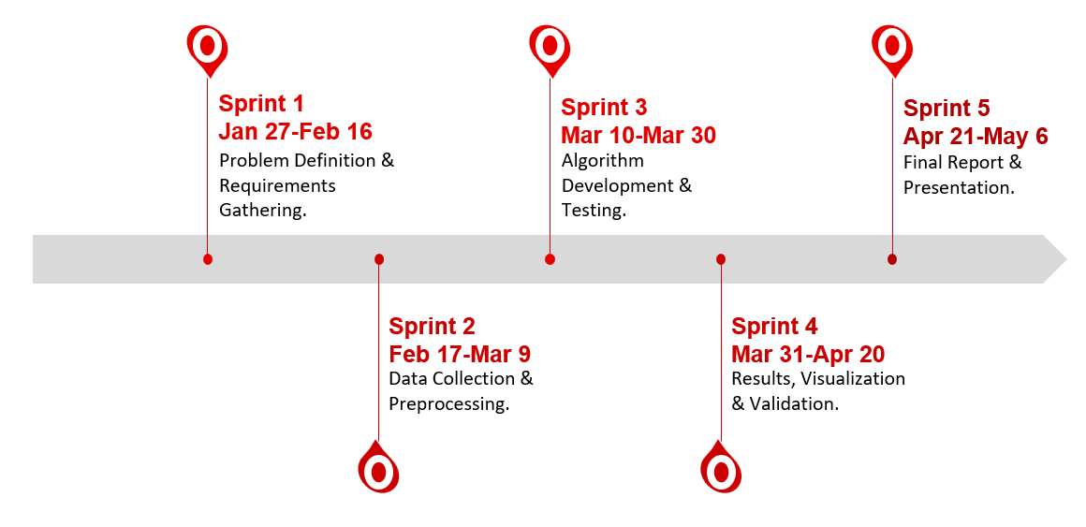

Figure 52: Sprint project dates.

Adapting the Scrum framework for our data analytics engineering project was a learning experience that gradually transformed into a highly effective workflow. Initially, our team faced challenges in writing clear and actionable user stories and defining proper exit criteria for tasks. This lack of clarity made the early sprints somewhat chaotic, as it was difficult to measure progress and align expectations. However, over time, the team grew more confident and skilled in breaking down the work into manageable stories with well-defined outcomes. A major contributor to this improvement was our use of the YouTrack tool, which proved to be extremely helpful in organizing tasks, tracking progress, assigning responsibilities, and maintaining proper documentation throughout the lifecycle of the project. While we didn’t hold standups every single day, we successfully conducted Scrum calls at least 4 to 5 days a week, which kept everyone in sync and fostered accountability. These frequent check-ins were instrumental in identifying blockers early and realigning priorities when necessary.

The transition to Scrum wasn’t without its hurdles, especially since our team came from mixed levels of familiarity with agile methodologies. Nonetheless, by the start of third sprint, we had established a good rhythm with planning meetings, sprint reviews, and retrospectives. One of the key lessons learned is that flexibility and consistent communication are vital in adapting Scrum to a technical, data-focused project. We also learned that investing time in upfront planning such as writing better user stories and defining technical dependencies pays off significantly later in the sprint. For future teams working on similar data projects, we strongly recommend embracing Scrum early, leaning on tools like YouTrack to stay organized, and not underestimating the power of regular (even if brief) team sync-ups. With persistence and iteration, Scrum can be a powerful framework even for data-heavy engineering workflows.

Sprint 1 Lessons Learned

In Sprint 1, the team focused on understanding the scope of the fentanyl precursors detection project. The challenge at this stage was defining precise user stories and setting clear exit criteria. Many initial tasks were broad and loosely defined, which made progress tracking difficult. However, by the end of the sprint, the team successfully outlined the system goals, established the basic structure for data modeling, and set up YouTrack for task tracking. This sprint emphasized the importance of early planning, documentation, and building alignment on deliverables across the team.

Sprint 2 Lessons Learned

During Sprint 2, the team concentrated on sourcing datasets and creating preprocessing pipelines for further analysis. Tasks were better defined compared to Sprint 1, and the team gained confidence using YouTrack to track progress and dependencies. Streamlit was initialized for UI prototyping, and backend tables were imported and structured. There were some difficulties managing Excel schema consistency and syncing fields between backend and frontend. The team improved communication through more frequent standups and began adopting best practices for data typing and model integrity

Sprint 3 Lessons Learned

Sprint 3 was focused on developing the logic behind the lookup system this included tagging logic, and backend integration with Streamlit. Key accomplishments included creating working dropdowns, and refining how the base user interface worked. User stories were now granular and better estimated. However, the team encountered challenges when parsing inconsistent Excel formats and aligning backend results with UI visualizations. Lessons learned included the value of modular design and the need for defensive programming to handle data anomalies.

Sprint 4 Lessons Learned

Sprint 4 marked the introduction of Secure GPT into the system. The team developed a pipeline for using GPT to generate insights related to evidences, which were then parsed, organized, and visualized. The frontend was updated to display GPT-generated content alongside other results (e.g., sources, weight tags). Challenges included handling unstructured GPT output and storing results consistently. This sprint also focused on polishing the UI, validating outputs, and ensuring a seamless user experience. The integration of AI into the data workflow was a major step forward, and the team gained insight into the importance of structured storage for AI-derived data

Sprint 5 Lessons Learned

During Sprint 5, our team focused on finalizing the application, polishing the user interface, and preparing for the final presentation. We began by identifying the key user stories based on feedback from previous sprints. These included improving the UI layout, structuring search result cards with separate sections for substance, synonym, and weight information, and ensuring all registry links were displayed accurately. We also added backend support to cleanly fetch and separate multiple sources related to each substance.

Task management during this sprint was moderately challenging due to overlapping responsibilities between development and presentation preparation. While most of the technical updates were completed on time, switching our focus to presentation mode caused some scheduling conflicts. The team did well in managing and prioritizing final UI edits and dividing presentation responsibilities. We used mock sessions to improve delivery and ensure each member was comfortable with their assigned section.

One of our key successes was implementing a “code freeze” before the final demo to avoid unexpected bugs. We also maintained consistent communication to align slide content with the current version of the application. However, we could have improved by starting the presentation planning earlier and scheduling more dry runs. We also learned that visual assets, like screenshots or demo walkthroughs, should be prepared as early as code updates are made.

Looking back, the team showed strong collaboration and adaptability. For future teams, we recommend locking in final deliverables ahead of time, clearly assigning slide ownership early in the sprint, and treating presentation work with the same level of planning as development tasks. Balancing demo readiness with technical polish is key to delivering a successful sprint outcome.

References

[1] pvilardo3164 and [Author removed at the request of original publisher], “7.1 drug use in history,” Social Problems Continuity and Change, <https://pressbooks.howardcc.edu/soci102/chapter/7-1-drug-use-in-history/> (accessed Feb. 2, 2025).

[2] “Facts about fentanyl,” DEA, <https://www.dea.gov/resources/facts-about-fentanyl> (accessed Feb. 2, 2025).

[3] F. Dews and V. Felbab-Brown, “The fentanyl pipeline and China’s role in the US opioid crisis,” *Brookings*, Oct. 2024. <https://www.brookings.edu/articles/the-fentanyl-pipeline-and-chinas-role-in-the-us-opioid-crisis> (accessed Feb. 03, 2025).

[4] We bought what’s needed to make millions of fentanyl pills–for $3,600, <https://www.reuters.com/investigates/special-report/drugs-fentanyl-supplychain/> (accessed Feb. 3, 2025).

 [5] Zinnia Health, “How much does fentanyl cost? (The street Prices) | Zinnia Health,” *Zinnia Health*, Sep. 13, 2023. <https://zinniahealth.com/substance-use/fentanyl/costs>

[6] USA Facts, “Are fentanyl overdose deaths rising in the US?,” *USA Facts*, Sep. 27, 2023. [Online]. Available: <https://usafacts.org/articles/are-fentanyl-overdose-deaths-rising-in-the-us/>

[7] “The fentanyl crisis requires ongoing and strategic federal action,” *ASTHO*. <https://www.astho.org/communications/blog/the-fentanyl-crisis-requires-ongoing-and-strategic-federal-action/#:~:text=These%20strategies%20include%20increasing%20access,to%20treatment%20and%20recovery%20services>.

[8] “Frontline Against Fentanyl | U.S. Customs and Border Protection,” *www.cbp.gov*, 2024. <https://www.cbp.gov/border-security/frontline-against-fentanyl>

[9] “Illicitly manufactured fentanyl–involved overdose deaths with detected xylazine - United States, January 2019–June 2022,” Centers for Disease Control and Prevention, <https://www.cdc.gov/mmwr/volumes/72/wr/mm7226a4.htm> (accessed Feb. 6, 2025).

[10] U. S. G. A. Office, “Illicit opioids: While greater attention given to combating synthetic opioids, agencies need to better assess their efforts,” Illicit Opioids: While Greater Attention Given to Combating Synthetic Opioids, Agencies Need to Better Assess their Efforts | U.S. GAO, <https://www.gao.gov/products/gao-18-205> (accessed Feb. 6, 2025).

[11] M. P. Prekupec, P. A. Mansky, and M. H. Baumann, “Misuse of novel Synthetic opioids: A deadly new trend,” Journal of addiction medicine, <https://pmc.ncbi.nlm.nih.gov/articles/PMC5537029/> (accessed Feb. 6, 2025).

[12] “United Nations Synthetic Drugs,” United Nations : Synthetic Drugs, <https://syntheticdrugs.unodc.org/> (accessed Feb. 6, 2025).

[13] “The Federal Register,” Federal Register :: Request Access, <https://www.federalregister.gov/documents/2023/10/24/2023-23478/special-surveillance-list-of-chemicals-products-materials-and-equipment-used-in-the-manufacture-of> (accessed Feb. 6, 2025).

[14] Defense, security, and justice | rand, <https://www.rand.org/randeurope/focus-areas/defence-security.html> (accessed Feb. 7, 2025).

**This page intentionally left blank**